Beyond the storm
Kei tua i te āwhā

Nelson’s Long Term Plan 2024-2034 Consultation Document

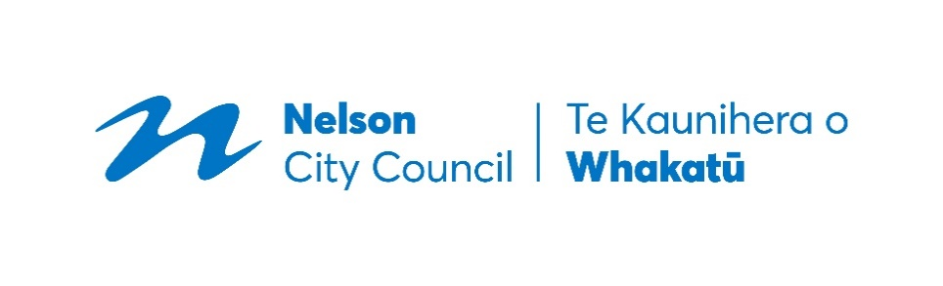

Contents

About this consultation document 3

Mayor’s foreword 4

Setting the scene 8

The key issues for feedback 12

Rates affordability 12

Buy-out of private properties affected by slips 17

Council’s forestry approach 23

Marina CCO proposal 26

Housing Reserve Fund changes 30

All-weather sports turf 32

Tāhunanui Beach facilities 34

Arts Hub 36

Other proposed projects and changes 38

Our financial approach 42

Other related consultations 49

Audit Opinion 50

How to have your say 52

About this consultation document
Hei kōrero āwhina
Welcome to Council's Long Term Plan 2024-2034 Consultation Document.
Every three years we develop a Long Term Plan for our city. The Plan covers the next 10 years (with more detail for the first three), describes the issues facing our city, what Council is aiming to achieve, how much it will cost, and how it will be paid for. Let us know what you think about the key issues we’ve outlined in this consultation document and your preferred options for dealing with them.
We haven’t included everything Council plans to do over the next 10 years or all of the background information that has informed our plans, in this consultation document. For this detail, take a look at the supporting information at nelson.govt.nz.

Long Term Plan Timeline
- Consultation opens: 27 March 2024
- Consultation closes: 28 April 2024
- Hearings: 9 and 10 May 2024
- Council deliberations: 23 and 24 May 2024
- Council adopts the Long Term Plan 2024-2034: 27 June 2024
- Long Term Plan comes into effect: 1 July 2024

How to have your say
To find out more about the different ways that you can give your feedback take a look at page 52.

Mayor’s foreword
Kupu whakataki
Introduction
There is much to love about Nelson. Our climate, natural environment and parks make us a mecca for recreation. We have a diverse economy driven by innovative businesses and a unique advantage as New Zealand’s seafood capital. Our creative arts sector and heritage facilities give our city character. We are a safe, caring and inclusive community. Our predecessors invested in good infrastructure. This consultation on the Long Term Plan for the next decade is about Council building on these strengths to ensure we remain the best little city in the best little country in the world.
Beyond the storm
The “Beyond the storm” title reflects two contexts in which this plan is being developed. The August 2022 weather event was the worst in 50 years and has had a huge impact on Council’s work and finances. Fixing the damaged infrastructure, finding a pragmatic solution for homes damaged or put at risk by landslides and securing financial support from the Government has dominated my first year as Mayor. The last big decision for Council related to the 2022 storm is how we meet the cost, and our proposal is for a $300 annual targeted rate for all separately used or inhabited parts of a rating unit in Nelson. We now have the opportunity to think beyond the storm on the longer-term challenges for our city.
It is not just a weather event that has made this Long Term Plan so challenging. We also have an economic storm with the highest inflation and interest rates in three decades and increased costs for Council in areas we cannot control such as depreciation, insurance and audit fees. We are very mindful that households and businesses are also facing the same economic pressures. Our challenge is to navigate a realistic and responsible financial path while ensuring we maintain and improve the services that support the city’s prosperity and wellbeing.
Our strategy
The underlying strategy in this proposed Long Term Plan is to take a cautious approach to new capital spending for any large civic projects over the next few years, while continuing preparatory work so those projects are ready to go once the economic situation improves. This reflects the difficult economic climate and the amount of storm recovery work that still needs to be completed.
We are aiming to get on with four smaller projects: A surf lifesaving facility at Tāhunanui Beach, a central city arts hub, an all-weather sports turf and supporting the Nelson Provincial Museum to deliver its project of a new Archives, Research and Collections facility (which is in the existing Long Term Plan). A city doing nothing goes backwards and we want to be progressively improving our facilities.
We believe there will be a need for investment in larger projects during the later years of this plan, such as Civic House. We are confident the economy will then be in better shape. Big projects also have long lead times and need broad community support. There will be further community consultation as this work progresses.

Infrastructure
Council’s greatest responsibility to our community is in the provision of vital city infrastructure for services such as drinking water, wastewater, stormwater, roads, stopbanks, drains, bridges, cycleways and footpaths. There is widespread concern across New Zealand that Councils have been underinvesting. This was a significant driver for the “Three Waters” reforms of the previous Government, which would have taken away from Councils control of these water assets.
Nelson’s infrastructure is in much better shape than it is for most Councils but we must continue to invest if we are to keep up with maintenance, provide for growth and better manage risks such as climate change. This draft plan provides over the next 10 years for an overall capital investment of around $815 million in key infrastructure. This includes a $128 million investment in drinking water infrastructure, $248 million for wastewater, $99 million for stormwater and $45 million for flood protection. We also propose capital expenditure of $295 million in transport infrastructure with a balanced approach between roading, public transport and active transport options such as walking and cycling.
Balancing risks and equity
There are important inherent questions in this consultation process over risk and intergenerational equity. We could choose to fund the storm repair costs over a greater number of years than the decade proposed but this increases the risk of not having paid for the 2022 event before we are hit again with another natural disaster. We also face choices about how much of the infrastructure we need should be funded from rates today, or from loans that will be paid in the future. We believe the approach proposed, with the debt cap rising from 175% to 200% of revenue, strikes an appropriate balance between keeping rates manageable today without placing an excessive burden on future generations.
Working together
This year, we celebrate 150 years of Nelson City Council. There is much we can be proud of in that long history. However, it is only in recent years that any attempt has been made to honour Te Tiriti o Waitangi / the Treaty of Waitangi and include iwi in decision making for our city and region.
Our Council’s ambition is to carve out a pragmatic pathway for our corner of New Zealand that builds respectful relationships with iwi and benefits the whole community. This is particularly important at this time when these issues nationally are becoming more divisive and difficult.
I was very involved as a then-Government Minister and Nelson MP in the settling of Te Tauihu treaty claims in 2014 and I am determined now, as Mayor, that these are honoured by our Council. On 12 December 2023, I signed, on behalf of Nelson City Council, the historic Kia Kotahi Te Tauihu, Together Te Tauihu Partnership Agreement along with our eight Te Tauihu iwi, and our two neighbouring local authorities of Tasman District Council and Marlborough District Council. The challenge now is to implement this agreement over the next decade in a way that builds confidence and shows the benefits of working together.

Opportunity for input
This consultation process gives you a say on the direction of your Council and your city for the next decade. There are no easy financial choices for Council in the current economic environment. Your Councillors and Council officers have worked hard over many months to find savings to constrain the effect on rates, but we acknowledge the increases proposed are still significant.
We welcome your thoughts on our priorities and choices. We invite you to focus particularly on the first three years of the plan. Although the Long Term Plan is for a decade, we are required to review and consult again in 2027. Be sure to comment on what you agree with as well as the proposals on which you disagree.
My ambition as Mayor is to lead a Council and community that works together, that gets good stuff done and spends public money wisely.

Ngā mihi nui,

Hon Dr Nick Smith
Mayor of Nelson | Te Kaunihera o Whakatū

Matters at a glance
Key Issues
Rates affordability, Page 12 | Buy-out of private properties affected by slips, Page 17
Council’s forestry approach, Page 23 | Marina CCO proposal, Page 26
Housing Reserve Fund changes, Page 30 | All-weather sports turf, Page 32
Tāhunanui Beach facilities, Page 34 | Arts Hub, Page 36

Other proposed projects and changes
Civic investment | Bridge to Better project
Recreational access to Ngāti Koata whenua | Extend East-West cycle way link
Crematorium | Trade Waste changes
Page 38.

Our Financial approach
Debt cap proposal | Recovery targeted rate
Changes to stormwater and flood protection rate
Page 42.

Setting the scene
Hei whakatakoto kaupapa
We live in a caring community in a beautiful area of Aotearoa New Zealand, but we have had our fair share of challenges lately. These have included natural disasters, cost of living pressures and the consequences of the pandemic. This Long Term Plan includes investments that will help us all move beyond these storms, adapt and thrive over the next 10 years.
The economy
Council is budgeting carefully during this time of increasing costs. That means finding savings where we can while continuing to pay for the essentials, including our roads, pipes, parks and buildings. We will also continue to invest in the services and facilities that make a real difference to you.
We expect these tough economic conditions will be with us for some time, so the Plan is particularly focused on containing costs as much as practicable. We plan to limit major new expenditure in the first three years, while progressing planning work for larger capital projects that can have longer lead times.
Climate change
Climate action is a key priority for Council and the Long Term Plan has many workstreams aimed at reducing carbon emissions and adapting to climate change impacts. Council is developing a Climate Strategy to sit alongside its existing Climate Action Plan to give the strategic context and long-term objectives for Nelson’s climate response. Work is continuing on adapting our city to deal with the impacts of climate change and growing our resilience.
In particular Council is taking an adaptive planning approach, as recommended by the Ministry for the Environment. A comprehensive regional climate change risk assessment is being completed in collaboration with Tasman District Council. This will enable a better understanding of climate change risks, and the consequential impacts on people, economy, governance, the built and natural environments. The risk assessment will inform Council’s identification and evaluation of a range of adaptation options. Community engagement will be a critical part of the identification and assessment of options.
Council also has a significant programme of work aimed at reducing its own operational emissions and supporting the Nelson community to reduce its emissions. Since the baseline year of 2017/18 Council has reduced its operational emissions by 89%, driven significantly by reductions in landfill emissions through infrastructure upgrades such as capturing methane and flaring. Work on further reductions in Council and community emissions is included across the 10 years of the Plan.
More people
Approximately 5,000 more people are likely to be living in Nelson by 2034. This will bring the population to nearly 61,000. Most of these people will be moving to Nelson, rather than being born here. And quite a lot of us will be older, with around one in four aged 65 or more. (At the moment, one in every five people is in this age group.)
Having 5,000 more people will boost our economy, but Council needs to make sure it can house a growing population. Council has also committed to both fostering a healthy environment and transforming the city centre to attract more people into the city to live, socialise and support local businesses.
Central government changes
Changing legislation and new requirements from central government will have direct impacts on the community and Council. For instance, the previous Government’s reform of three waters would have resulted in 10 publicly-owned water entities being created to manage New Zealand’s drinking water, wastewater, and stormwater networks.
However, the new Government isn’t proceeding with this approach and will legislate other changes over the next two years. We don't know the detail yet, so Council has chosen to include the proposed budgets for three waters services for the full 10 years of the Plan and will keep up to date with the Government’s reforms. We will also be monitoring the changes proposed to resource management legislation (how we regulate activities related to our buildings and the environment).
We have assumed the Government will continue to provide Council with a 51% subsidy for eligible aspects of the transport work programme. The total subsidised transportation work programme is approximately $393 million over 10 years including approximately $196 million of central government funding. Any Government decision to reduce funding to Council could have an impact on the work we can undertake or on rates and debt levels (refer Significant Forecasting Assumptions at nelson.govt.nz for further information). We welcome the Government’s recently published draft Government Policy Statement on land transport (GPS) 2024 that increases land transport funding by 30% on the previous 2021 GPS, albeit the change in priorities of the new Government may shift the balance of the projects for which we will receive central government funding.
Working together
We work with our iwi partners, community organisations, neighbouring councils, and Central Government to make life better in Nelson. More details on how we will strengthen our partnership with iwi and Māori are available in the ‘Statement on Fostering Māori Participation in Council Decision Making’ at nelson.govt.nz.
Nelson City Council and Tasman District Council already work together where this allows us to deliver better, lower cost services in both areas, and we are looking to further this collaboration wherever it makes sense. We also work closely with Central Government agencies to access funding and support for local projects.
Vision, priorities and outcomes
Council has developed a vision and three overarching priorities to guide our work programmes for the next 10 years.
Our vision for Whakatū Nelson is a creative, prosperous, and innovative city. Our community is inclusive, resilient, and connected – we care for each other and our environment.

Our priorities are to:
- Support our communities to be prosperous, connected, and inclusive
- Transform our city and commercial centres to be thriving, accessible and people-focused
- Foster a healthy environment and a climate resilient, low-emissions community
Our eight community outcomes are broad, long-term goals that guide our overall direction – read more about them in the supporting information at nelson.govt.nz.
Continuing to invest in our community over the next 10 years
Council undertakes a huge range of work that supports and influences your daily life. We are asking for your views on eight key issues, but there is much, much more that we will be tackling over the next 10 years. A selection of projects and investments that we will progress over the course of the Plan are highlighted below.

Infrastructure Projects
Defining options for the future location and disposal route for the Nelson Wastewater Treatment Plant, over 2024-2034 years, $630,000. | Completing Bridge to Better project in 2027/28. Council funding up to $42.4 million and Government funding of $36.3 million. | Increasing the rate of wastewater pipe renewals, $99.3 million across the 10 years.
Detailed design and obtaining resource consents for the Atawhai Rising Main in 2024/25 and then starting the construction, 2024– 2033, $58.7 million. | Flood protection capital works, 2024 -2034 years, $45.3 million. | Investing in transport including:  - Intersection improvements / upgrades from 2024/25 to 2030/31, $8 million.  - Improving public transport infrastructure over 2024 -2034 years, $9 million.
Parks and Facilities
Renewal of parks assets including:  - Play equipment, 2024-2034, $2 million.  Wakefield Quay sea wall, by year 2028/29, $2.2 million. | Investing to maintain our existing aquatic facilities, $7.6 million across the 10 years to 2034. | Developing Rutherford Park play space by 2025/26. $2.4 million of ‘Better Off Funding’ plus $600,000 additional Council funding.
Arts and Culture |  | City centre revitalisation
Supporting activities that contribute to a thriving arts and creativity scene. | Supporting the Nelson Provincial Museum to build a new Archives, Research and Collections facility. | Implementing Te Ara ō Whakatū City Centre Spatial Plan through revitalisation of city centre spaces, 2024-2034, $4.2 million.
Waste Projects | Being Prepared
Continuing to support diversion of waste from landfill, 2024-2034 $47.1 million. | Preparing for a range of hazards and risks that might occur in the region including:  - South Island wide rupture of the Alpine Fault  - Tsunami. | Resolving risks associated with Council’s earthquake prone buildings.
You can find the ‘Other proposed projects and changes’ section on pages 38-41 and our activity summaries in the supporting information at nelson.govt.nz

The key issues for feedback
Ko ngā kaupapa matua
The following are eight key issues that are priorities for Council and which we particularly want to hear from you on so that our way forward can be guided by the community.

Rates affordability
To limit rates rises, we need to make some hard decisions about trade-offs.
Balancing the budget
Like every other council around New Zealand, we are facing rising costs. Council currently spends approximately $170 million each year on services and manages $2.4 billion of assets.
Our rates, our debt, and our capital spending (using long term loans) are the three financial ‘levers’ that influence what services we can provide. But how should we adjust these ‘levers’? We are looking for ways to make savings, and this includes deciding what to invest in now and what to put off until later. We need to make sure we are not unfairly loading costs onto future residents. We also need to weigh up what we would like to do compared to what we can afford to do.
Financial pressure points
This Long Term Plan has been developed in a ‘perfect storm’ of financial pressures including inflation, high interest rates, and more expensive insurance. Between the Annual Plan 2023/24 and 2024/25, it’s estimated our interest costs to service our debt will increase by $4.2 million and our insurance costs by $752,000. The value of our infrastructure assets (such as pipes, roads and buildings) has significantly increased over the past few years to $1.85 billion, in part because of a sharp rise in construction costs. This means we need to put more money aside to replace them in the future, with an additional $1.5 million in depreciation funding in 2024/25.
Government reforms and changes in legislation (such as changing environmental standards and emergency management requirements) also increase our costs. Rising prices for both contracted labour and materials means it now costs more to provide our normal services and to complete projects.
The severe weather event in August 2022 caused massive flooding and landslides, which has had a major impact on our finances. Council has decided to build back better to make the city’s infrastructure more resilient, but that comes with a higher price tag. The total estimated cost of the recovery is $87.2 million, with some of this to be paid for by insurance and central government. That leaves about $60 million for us to pay.
At the same time, Council is keenly aware that high prices are putting pressure on everyone’s finances, making it even harder to pay for rates. Council wants to limit the level of rate rises where we can, to avoid making things more difficult for you.
Our proposed approach
Our plan is to keep rates rises as low as possible while maintaining core services, paying for the recovery, and continuing to invest in the projects that will make the most difference to Nelson’s future.
Something has to give. We need to make some difficult decisions on what services to stop providing, reduce in frequency, or provide to a different standard and what projects to remove from our to-do list. Other ways to save money include delaying some work and working more efficiently. We are proposing some changes to the rating system, including spreading the load of paying for the recovery more evenly across the whole community (see box below). More details about rating changes are discussed in the Draft Revenue and Financing Policy at nelson.govt.nz.
If all these changes are made, the average rates rise would be 8.2% plus a $300 (including GST) Storm Recovery Charge in 2024/25 (15.3% inclusive of the Storm Recovery Charge), and subsequent average rates rises over the next nine years would be between 1.7% to 5.4%.

Paying off the recovery
We will pay for the recovery works from the August 2022 severe weather event over the next 10 years. We need to pay this off over a relatively short period because we expect more natural disasters and intense storm events to come our way in the future. Paying off this debt faster means higher costs in the short term.
We think a targeted rate of $300 (including GST) for 10 years for all separately used or inhabited parts of a rating unit (SUIP) in Nelson is the most transparent way to pay for the recovery. Council’s view is that a uniform charge is appropriate when considered with other rating proposal changes relating to stormwater and flood protection. See ‘Our financial approach’ on page 46 and the ‘other related consultation’ on the Draft Revenue and Financing Policy for more details about this proposal at nelson.govt.nz.
How will this approach affect Council services?
The total impact of the savings we are proposing is major when considered as a whole package. That’s why we want to hear from you before making a final decision.
We can take an alternative approach and continue to fund services as we do now, but remember that this will result in a higher rates rise for the community.
We have listed some examples below – and more details are available in the Activity Summaries in the supporting information at nelson.govt.nz.
We plan to cap funding for maintenance at current rates for a wide range of water infrastructure, transport, property, facilities and parks, and active recreation assets – rather than increasing them to reflect cost increases. We will continue to maintain essential infrastructure that we rely on to protect health and safety but we will be more selective in the maintenance that we undertake across our other assets. You may notice a reduction in the frequency or the standard of some maintenance, for example:
- Reducing the budget for line marking on roads from $200,000 per year to $110,000 for 2024/25 will decrease the frequency that lines are repainted on low volume roads, cycle lanes and parking areas.
- Not increasing parks contracts for inflation in 2024/25 will save approximately $500,000. This will reduce some services and the frequency of some maintenance across our parks and reserves.
Another way we can save money is to cap some of our activity budgets at existing levels rather than raising them to match cost increases, or decide not to carry out new actions in recently approved strategies. This means Council will be selective about the services we continue to provide and how we respond to new legislative requirements. For example:
- Deferring some of the science and environment budgets means we will continue to undertake air quality data collection but decrease the regularity of reporting.
- Keeping heritage budgets at existing levels will mean not implementing the new actions in the recently adopted Taonga Tuku Iho Strategy (Heritage Strategy).
In some situations, a reduced budget will mean the removal of, or reduction in, something currently provided. For example:
- Delaying the expansion of the weed control programme in landscape reserves by a year will reduce the 2024/25 budget from a planned $1.2 million in the last Long Term Plan to $480,000 (saving $720,000).
- Divesting Council’s crematorium service at Wakapuaka Cemetery in Atawhai from 2025/26 will have a net budget saving of approximately $163,000 per year.
The impact that a saving can have on rates depends on whether it is operational or capital expenditure:
- Operational expenditure pays for people’s time, ongoing services, maintenance and interest on debt, and needs to be paid for immediately (from rates received that year).
- Capital expenditure pays for things (such as pipes and footpaths) and is funded by debt. Just like a mortgage, these costs are paid off over a long period of time (commonly 80–100 years).
- This means that a major project worth tens of millions of dollars can have a smaller impact on rates in any one year than an operational expenditure worth a fraction of the cost, but interest will be charged each year until the debt has been paid off.
What other financial mechanisms are proposed to minimise the rates rise?
Council has an extensive network of assets to support the smooth functioning of the city and wellbeing of the community. Many of these assets (e.g., water and wastewater pipes and ageing council facilities) will reach the end of their lives over the next couple of decades and we will be faced with a ‘bow wave’ of renewals. To help us manage this, we will bring forward some renewals, and increase our spending on renewals from an average budget of $23.2 million per year in the Long Term Plan 2021-2031 to an average of $43.6 million per year over the next 10 years.
As part of bringing forward some renewals and cutting others, we have considered our capital works programme carefully and focused on essential renewals. We have achieved a balance which will enable key infrastructure renewals to occur within our financial constraints.
This will have an impact on our debt. Although it will remain within our proposed debt cap of 200%, net debt is projected to rise from $248 million in 2024/25 to $526 million in 2033/34. Our increased debt and the projected interest rates over the next 10 years, means our interest costs are projected to increase from $7.7 million in the Annual Plan 2023/24 to $32.3 million at the end of 2034.
As mentioned above, our infrastructure assets have been revalued at a higher level, which means we need to put more money aside to replace them in future (when they wear out). We propose phasing in these additional depreciation costs of $4.1 million over 10 years to reduce the rates increases over the 10 years of the Plan. Also, our insurance costs have increased due to these higher valuations and it is more difficult and expensive to secure insurance cover following severe weather events globally. We will undertake a review of Council’s insurance (insurance optimisation) to limit some of these increases.
To lessen the burden on ratepayers we have also reviewed our schedule of fees and charges with the aim of moving more of the costs onto the specific users of services and decreasing the subsidy paid by the community as a whole. You can read more about how to provide feedback on fees and charges changes on page 49.
What are the options for rates affordability?
- Option 1 – Fewer service cuts and higher rates increases. Accept higher rates increases to keep services and maintenance standards and frequency at levels similar to current practice.
- Option 2 (Council’s proposal) – Medium service cuts and medium rates increases. Balance rates rises with providing services/some new projects and accept some reductions in services and maintenance standards and frequency.
- Option 3 – Big service cuts and lower rates increases. Reduce the rates increase by making cuts to core services and maintenance levels.
Fewer service cuts and higher rates increases Option 1
Accept higher rates increases to keep services and maintenance standards and frequency at levels similar to current practice.
This option would continue proactive maintenance and service delivery and maintain momentum in enhancing services to the community across all activity areas. Examples of the work that could be added into budgets would be reinstating operating funding for inflation for utilities infrastructure, transport, property, events, facilities and parks and reserves maintenance contracts; increasing the frequency of reporting on environmental monitoring; increasing weed control; and increasing operating funding for climate change strategic planning in the infrastructure activity.
The trade-off would be that this option has the highest immediate cost to ratepayers and community expectations remain at levels that may not be sustainable in the long term.
The exact cost increases would depend on what additional work Council undertakes. Some activities and projects will have a greater impact on rates and others on debt. For an additional $950,000 of operating expenditure or approximately $15 million capital expenditure added to Council’s annual work programme, an additional 1% would be added to rates.
Medium service cuts and medium rates increases (Council’s proposal) Option 2
Balance rates rises with providing services/some new projects and accept some reductions in services and maintenance standards and frequency. As Council’s proposal, this option aligns with our draft Long Term Plan budgets (as they stand now) and will deliver our work programmes across Council’s 11 activity areas. Although rates will increase above current levels, this option would provide some financial relief for the community during the current cost of living pressures, while maintaining good financial management and performance. It would allow for continued investment across activity areas to support community wellbeing and progress projects and key renewals for the city’s future.
Disadvantages would include some maintenance being less proactive, services to customers or stakeholders being less responsive, and some increased risk of asset failures and unbudgeted repairs.
As outlined earlier in this section, this option would limit the average rates rises to 8.2% plus a $300 (including GST) Storm Recovery Charge in 2024/25, and subsequent average rates rises over the next nine years of between 1.7% to 5.4%. Projected net debt would increase from $208 million in June 2024 to $526 million in 2034.
Big service cuts and lower rates increases Option 3
Reduce the rates increase by reducing Council’s work programme further. This option would involve a series of further cuts to already reduced budgets. Cuts would be spread across many activities and projects to avoid a major impact on any single one.
Examples of the types of further cuts that could be made are reducing the opening hours of the Council Customer Service Centre or reducing our spending on reactive maintenance in our parks and community facilities which would reduce our responsiveness (this could mean, for example, less cleaning of toilets or mowing of grass in response to community requests).
This option would further ease the financial impact on ratepayers, in an environment of cost of living pressures, but would increase the risk of asset failures and unbudgeted repairs, require deferring of some renewals and would be expected to impact on community wellbeing through reductions in service delivery in a wide range of areas. It would add costs to Council and our ratepayers in the long term.
We consider that it would be very difficult to make further cuts without undermining the services that support our city’s prosperity and wellbeing, and imposing additional costs on future generations.
The exact cost implications would depend on what additional cuts Council makes as some would reduce rates funding required and others would reduce long-term debt. For each additional 1% decrease in rates, $950,000 operating expenditure or approximately $15 million capital expenditure would need to be removed from Council’s annual work programme.
Which option do you support?
Have your say on this key issue – see page 52 on how to submit.

Buy-out of private properties affected by slips
We have choices to make about purchasing private properties that were impacted by slips during the August 2022 severe weather event.
Background
The August 2022 severe weather event caused significant damage to the region, including to private property. Some Nelsonians have suffered damage to their properties and face uncertain futures. Council wants to support the most affected residents but we need to know what you think about the options available.
Central Government cost-sharing support package
The Mayor of Nelson has advocated strongly on behalf of our region and has been successful in securing a one-off deal for Nelson which is similar to those offered to North Island regions affected by Cyclone Gabrielle / severe weather events.
The Government has offered to pay up to $12.3 million to support the city’s recovery:
- $6 million towards repairing slips from public land so that land is safer than it was before the event. This amount is 50% of the betterment portion in dealing with slips that have originated on Council land and are affecting private properties. (Betterment here means improving resilience instead of like-for-like replacement.)
- $300,000 towards ongoing monitoring of the Tāhunanui slump ($30,000 per year over the next decade).
- $6 million (which is 50% of the total cost less any pay-outs from other sources like home insurance) to purchase up to 14 impacted properties where the landslide risk is too high for the property owners to return to their homes, and the cost of works to reduce that risk is prohibitive.
Like the offers to North Island regions, the support is offered as a package – Council needs to accept all three parts to be able to access the funding. Council has accepted the support package offer subject to consulting with the community on the buy-out component.
The buy-out support offer
Central Government is offering to support buy-out of properties that have been severely impacted as a result of the August 2022 severe weather event, where there is an intolerable risk to life and it is not feasible to mitigate that risk. These are similar to properties that have been “red-stickered” as a result of the severe weather-event.
The offer to contribute to buy-outs is based on a $6 million cap from Central Government with Council contributing the other 50%. It also comes with conditions on Council, including responsibility to:
- liaise with affected residents, administer the overall programme of all purchases, and manage insurance claims that are assigned to Council
- take ownership of the land purchased and ongoing management of that land (including demolition).
The cost of any buy-outs will be less any Toka Tū Ake Earthquake Commission (EQC) and insurance settlements that property owners have received or will receive for damage to their properties. And any buy-out would be voluntary for property owners.
We want to hear your views on the buy-out support offer
Council is proposing to accept the Central Government buy-out support offer and purchase up to 14 eligible private properties impacted by slips from both public land and private land.
Progressing these buy-outs would aid the wellbeing of the affected property owners.
Taking this approach has costs and requires careful consideration. So, we want to understand if you support Council purchasing private properties affected by slips before making a final decision.
Although there is no distinction in the Central Government offer, there are two different categories in the buy-out approach:
- private properties impacted by slips from public (i.e. Council) land
- private properties impacted by slips from private land.
Council has certain obligations, as a neighbouring landowner, to private properties impacted by slips from its (public) land. In this situation, Council may choose to purchase individual properties on a case-by-case basis. For instance, we are doing this in relation to some properties impacted by slips from Council land in the Brook Valley.
Council does not have any such obligations where slips are from private land.
To purchase properties affected by slips from private land would be a significant new activity for Council, as Council has no obligation to get involved and there are ongoing financial consequences for Nelson residents from taking ownership of slip-prone land, including immediate remediation costs and costs of managing future instability. Council would not contemplate these purchases of private property if it was not for the 50% funding offer from Central Government.
Eligibility buy-out principles
We would also like to hear your views on the eligibility buy-out principles (the methodology for eligibility and buy-outs required by Central Government) that would apply to any purchases (see the full draft eligibility principles in the background information at nelson.govt.nz). Central Government requires these principles to be reasonably consistent with the approaches adopted by the weather event affected North Island councils.
The principles Council is proposing incorporate principles relating to eligibility and a fair purchase price and include the following: homes that are not insured would be purchased for a lesser amount (maximum of 80% of market value pre August 2022) than those that are insured (maximum of 95% of market value pre August 2022), given that insurance payouts will reduce the total purchase price required. Council would not contribute towards relocation costs and Council’s offer would lapse after 12 months.
If Council proceeds with the buy-out of property, we will likely use some of the Central Government funding to offset already completed property purchases that are eligible under the support package funding agreement.

What are the likely costs of progressing with the buy-outs?
As noted above, it is a condition that Council has to take on full responsibility for the ongoing land management of any properties purchased and the associated costs.
The final costs to Council will vary depending on the final eligibility buy-out principles and what work needs to be done on purchased properties to lower the risk of future slips. After taking into account the $6 million funding from Central Government for the buy-outs, the estimated remaining cost to Council could include:
- up to $6 million as Council’s share to purchase up to 14 properties
- up to approximately $2.5 million to remove structures
- up to $4 to $8 million for slip remedial works
- up to $ 1 million for administrative and other costs resulting from the buy-outs
- potential future costs to manage ongoing instability and other as yet unknown risks relating to purchased properties.
Will it set an expectation for the future?
No matter the final decision, we need to be clear this is a one-off response to a specific situation and we do not consider that it sets an expectation for the future. The community should not expect Central Government or Council to take the same approach if private properties become unliveable following future weather events. However, we do understand the concerns that participating in the buy-out could potentially create some sort of expectation for our Council. We emphasise that Council’s response to any future event would depend on its own unique facts and circumstances..
Council is looking at how hazards and slip risks can be better mitigated in the future, including improving planning rules. We will be asking Central Government to hold a national conversation about how the fallout from severe weather events is paid for in future, particularly in respect of the role of EQC where properties are undamaged but unsafe to live in due to landslide risk.
What are Council’s options for the Central Government buy-out support offer?
- Option 1 – Don’t accept it.
- Option 2 (Council’s proposal) – Accept it and apply the draft eligibility buy-out principles.
- Option 3 – Accept it and apply amended eligibility buy-out principles.
- Option 4 – Seek to renegotiate with Central Government.
Don’t accept the buy-out support offer Option 1
This option would mean we would not carry out a programme of voluntary buy-outs for residential properties impacted by slips. This is the lowest cost option for Council (and the community as a whole) as it avoids purchase costs and the ongoing costs once we take responsibility for slip-prone land. However, all of the $12.3 million Central Government funding would be lost and Council would need to cover all of the costs for monitoring the Tāhunanui slump and the betterment portion of public land slip repairs.
This option protects the community from subsidising risks and liabilities impacting private property owners, where there is no current obligation for Council to provide financial assistance. However, this would leave those property owners with ongoing uncertainty as to their future, as they are unlikely to be able to afford repair costs that exceeds the property’s value, and won’t be able to live in the properties because of the risks. Slip-related issues on the private properties are unlikely to be resolved, with properties left derelict and with the potential to cause additional damage and costs to the community during future storm events.
In the proposed Long Term Plan budgets, Council has provided for $6 million towards the purchase of private properties. This $6 million would be removed, while the other recovery costs would need to proceed as planned. Council would also lose access to the $12.3 million funding provided by Central Government. Therefore, the total cost of this option would be $6.3 million.
Impact on rates: Additional $6.3 million of rates to repay the additional debt over the 10 years of the Plan. There would also be additional interest to be funded by rates annually on the outstanding balance of the $6.3 million until it is fully repaid. This would be $306,000 in year 1, with the amount per year decreasing as the balance reduces.
Impact on debt: Additional $6.3 million of debt to be repaid over the 10 years of the Plan.
Accept the buy-out support offer and apply the draft eligibility buy-out principles (Council’s proposal) Option 2
This option would involve purchasing up to 14 eligible properties impacted by slips from public and private land. The draft eligibility buy-out principles would apply to purchases, including maximum payment of 95% of the market value for insured properties and 80% of the market value for uninsured properties. Council will assess properties against the final eligibility buy-out principles, however at this time we are unaware of any potentially eligible properties being uninsured. Council’s contribution to purchasing properties would be capped at a maximum of $6 million to match the 50% funding offered by Central Government and depending on the number of eligible properties these percentages may need to be adjusted to fit within that cap.
It would support Nelson’s most affected property owners, no matter the origin of the damaging slips, and give them a purchase price which is close to the market value of their home. This option would secure the rest of the Central Government funding for other resilience and risk mitigation projects.
Having different percentages for insured or uninsured properties makes clear that Council is not the insurer of last resort. While this is a one-off package, it highlights for the community the importance of being responsible for their own insurance and reflects private insurance pay-outs. It would also align with the buy-out approaches of other North Island councils, such as Auckland Council.
On the other hand, Council (and the community as a whole) would take over the current property owners’ liabilities as the new owner. This could also create an unrealistic expectation that Council will take the same approach to damaged properties in the future.
This option would be one of the most expensive with ongoing financial consequences for the community due to taking ownership of slip-prone land, including short-term remediation costs and any future land management costs.
The remaining cost to Council (after up to $6 million Central Government buy-out funding taken into account) is estimated to range up to $13.5 to $17.5 million over the 10 year period. Council has provisionally budgeted for $6 million of this cost in the Plan. The timing and amount of the remaining costs are too uncertain at this stage to include in our budgets.
Impact on rates: $6 million of the $13.5 to $17.5 million has already been included in the proposed Long Term Plan budgets, and is proposed to be repaid by the $300 (including GST) Storm Recovery Charge over the 10 years of the Plan. The remaining costs and repayment timing will be budgeted when we have more certainty.
Impact on debt: As outlined above, $6 million of additional debt is included in the proposed Long Term Plan budgets (and repaid from the recovery targeted rate). Additional debt will be budgeted when we have more certainty on costs.
Accept the offer and apply amended eligibility buy-out principles Option 3
This option would involve purchasing up to 14 eligible properties impacted by slips from public and private land. The draft eligibility buy-out principles would be amended to incorporate feedback on how best to set a fair purchase price, subject to what Central Government will accept as being consistent with the approach of the North Island councils.
This option would have many of the same advantages and disadvantages of option 2. The key difference would relate to the upfront purchase costs. Alternative eligibility buy-out principles are summarised below, and could include others suggested by the community through this consultation.
We could, for example, set a maximum purchase price of up to the Nelson median house price (which is $765,000 based on sales for the 12-month period prior to August 2022). This would limit the initial cost to the community for something Council is not required to do. Owners of higher-value properties would likely receive a lower proportion of their property’s value compared to the proportion received by owners of lower-value properties.
We could proceed with purchases at 100% of market value (based on a market valuation pre-August 2022). This would mean property owners would receive full compensation, which is the approach taken by some North Island councils. This would support affected property owners’ wellbeing, particularly property owners with higher-value properties who would receive buy-outs that match the asset’s value. However, it would result in the highest upfront costs to the community.
We could apply lower maximum purchase prices for properties impacted by slips from private land of 75% of the market value. This principle would recognise that Council has no legal obligation to purchase properties impacted by slips from private land and that acquiring this slip-prone land will expose Nelson residents to more ongoing costs. The savings to upfront costs would help with the expected ongoing land management costs, while still providing a reasonable level of support for the wellbeing of affected property owners.
For all of the above alternative principles we could differentiate between insured and uninsured properties where 15% less would be offered to owners of uninsured properties. This would recognise the greater cost to the community of purchasing uninsured properties and the responsibility of property owners to protect their asset.
The remaining cost to Council (after Central Government buy-out funding is taken into account) could increase or decrease the upfront costs compared to option 2 depending on the eligibility buy-out principles chosen. The costs are estimated to range up to $12.5 million to $18 million over the 10 year period. Council has provisionally budgeted for $6 million of this cost in the Plan. The timing and amount of remaining costs are too uncertain at this stage to estimate.
Impact on rates: $6 million of the $12.5 to $18 million has already been included in the proposed Long Term Plan budgets, and is proposed to be repaid by the $300 (including GST) Storm Recovery Charge over the 10 years of the Plan. The remaining costs and repayment timing will be budgeted when we have more certainty.
Impact on debt: As outlined above, $6 million of additional debt is included in the proposed Long Term Plan budgets (and repaid from the recovery targeted rate). Additional debt will be budgeted when we have more certainty on costs.
Seek to renegotiate the buy-out offer with Central Government Option 4
This option would involve Council attempting to renegotiate the terms of the buy-out support offer with the new Government to target properties impacted by slips from Council land only.
This option would avoid Council entering into a significant new activity of purchasing properties impacted by slips from private land when it has no legal obligation to do so. It would set a clear expectation that Council will not subsidise private individuals’ risks and liabilities related to slips on privately owned land. If successful, this option would limit the number of properties purchased and level of responsibility and cost taken on by Council to manage land purchased.
The key downsides are it would not provide certainty for affected property owners impacted by slips from private land and would delay resolving slip issues, running the risk of potential further damage during future storm events. Also, it is a high risk option – Central Government is unlikely to support a change in the intent of their support package and all of the $12.3 million funding could be lost to Council.
There would be less immediate cost to Council, except for prioritising staff resources to renegotiate with Central Government. Following negotiations there may be a decreased cost to progress more targeted buy-outs, however there is an increased risk that Central Government funding would no longer be available. The likely impact on rates and debt would depend on the renegotiation, so the implications are unclear at this stage.
Which option do you support?
Have your say on this key issue – see page 52 on how to submit.

Council’s forestry approach
Nelson has an opportunity to move away from commercial forestry over time and to manage all its forests in a way that is better for our environment.
Council owns and manages approximately 600 hectares of commercial forestry in its Maitai, Brook, Roding and Marsden reserves (including water and conservation reserves) which the public have access to. For several years Council has been debating whether or not planting and harvesting pine forests is a good idea – both financially and environmentally.
Council is proposing to transition away from commercial forestry and manage all its forests in a different way. Now we need to hear from you and then decide whether to progress with this change or stay with our current approach.
Background
The Right Tree Right Place Taskforce (made up of elected members and independent specialists) was set up in early 2023 to look at all the options for Council’s commercial forestry land. The Taskforce recommended Council transition away from commercial pine forestry and to replant with a continuous canopy of mixed species (following Pinus Radiata stands being harvested, removed or transitioned). You can read the Taskforce’s report in the background information at nelson.govt.nz.
This approach would involve planting a mixture of high value native and exotic trees and leaving them to grow into forest. Future generations may have the option to selectively harvest high value timber from the forests, but the intention is to maintain continuous canopy forests. Council supports this new approach but wants your feedback before making a final decision.
Nelson – the forest city
In addition to moving away from commercial forestry, the Taskforce has also recommended managing all of Council’s 10,000+ hectares of forests as one area – including all the pine trees and native bush. It would take time to transition to thriving, biodiverse continuous canopy forests but no other New Zealand city has the benefit of such a large forest area on its doorstep, and this change in approach would enhance its conservation and recreation value.
Our changing climate makes this area even more important, as having protected and thriving mixed-species forests in place over the long term will absorb and store carbon, improve water quality by stabilising the soil on our steep hillsides, and avoid the risk of forestry slash causing problems during heavy rain events.
How is the forestry activity funded?
Council’s commercial forestry operations are currently funded from a closed account. This means Council treats commercial forestry as a separate bank account and does not transfer rates money into this account or take money out to pay for other activities.
Moving out of commercial forestry and changing over to the new approach would require funding from rates. There are some additional options that may help fund this new approach:
- possible income from carbon, voluntary carbon and biodiversity credits
- taking out loans and seeking grants and external co-funding
- selling the rights to cut down existing pine trees.
Our proposed approach
Notwithstanding the recommended change in approach, Council will as a first priority work to ensure that Emissions Trading Scheme obligations are met. We will also spray weeds and replant as a priority with mixed species, in areas where pine trees have been cut down but not yet replanted. This will help us minimise risks relating to these areas in future weather events.
Funding has also been included to work through the full extent of the change in direction, including options to progress the longer term transition, potential funding sources to support the transition, and what the future of Nelson’s 10,000+ hectares of forests will look like for Council and the community.
What are the options for Council’s forestry?
- Option one – Retain our current commercial forestry approach.
- Option two (Council’s proposal) – Change our approach. Exit commercial forestry over time and grow a continuous canopy of mixed species. This would be managed as one area and would improve recreational access particularly on the fringe of the city.
Retain our current commercial forestry approach Option one
This option would continue the planting and harvesting of pine trees on Council’s reserves. Retaining the current approach would provide more financial certainty and avoid rework of existing harvesting plans. However, it would not lead to better management of all of Council’s forested lands or improved environmental, recreational and social outcomes, when considering slope instability, erosion and sedimentation, effects on aquatic life, soil degradation and poor visual amenity and biodiversity outcomes.
Over and above the standard yearly forestry activity costs, the estimated costs of this option are $600,000 across the 10 years of this Plan. The estimated cost to replant the remaining commercial forestry land in pine trees over the longer term is in the range of $950,000 to $1.3 million, which would be offset by harvesting income.
It would have no impact on rates and $600,000 additional debt within the 10 years of the Long Term Plan.
Exit commercial forestry (Council’s proposal) Option two
This option would see an exit from commercial forestry over time, with forests to be replaced with a continuous canopy of mixed species. It is more expensive but would allow Council to take a holistic approach to management of its native and exotic forests and develop a long-term asset for the community with improved environmental, recreational and social outcomes, particularly on the city fringe.
It would maximise community amenity and recreational values and offer environmental and climate benefits (such as permanent carbon sequestration and flood mitigation) and likely increase levels of service. It creates the potential to develop a plan for the whole 10,000 hectares of forest owned by the Council to address biodiversity concerns such as pest control, habitat protection and invasive weeds.
The disadvantages would be increased costs and some economic impact on the forestry sector by removing Council’s small commercial forestry (less than 1% of the Nelson-Tasman region’s commercial forestry) from the current harvesting and replanting process.
Over and above the standard yearly forestry activity costs, the estimated costs of this option is $9.8 million of additional funding across the 10 years of the Plan to progress the transition. The estimated cost for transitioning the remaining forestry over the longer term is in the range of $4.6 million to $29.2 million, some of which could be offset by income.
Impact on rates: Total of $3.4 million across the 10 years of the Long Term Plan.
Impact on debt: $9.8 million by year 10 of the Long Term Plan.

Which option do you support?
Have your say on this key issue – see page 52 on how to submit.

Marina CCO proposal
Nelson has an opportunity to support the success of the Nelson Marina by moving to an Asset-Owning Council Controlled Organisation.
Background
Council aims to strengthen Nelson’s links to the ocean and grow the city’s standing as a centre for marine industries and activities. We see the Nelson Marina’s development as an important next step on the way to achieving this goal.
The Marina is in a central location, linking city to sea and providing recreational boating access to the waters of Tasman Bay and Marlborough Sounds. Marina berths are in high demand with up to a four year waiting list for berths up to 14 metres and a longer wait for those over 14 metres. But more needs to be done to realise the potential of this city asset and to meet existing and future demand. The recently adopted Nelson Marina Masterplan sets out the medium-term vision to transform the Marina into a modern, world-class facility for both boaties and the community to enjoy.
Council plans to invest $60 million to implement the Masterplan over the next 10 years. This will greatly enhance this valuable asset and destination for the whole community and provide modern facilities to meet the changing needs of boat owners, commercial operators, marine contractors and sea sport participants.
Council embarked on a journey to transform the marina in 2021 when it took over active management of the facility. We then in 2023 established a Management Council Controlled Organisation (Management CCO) to manage the Nelson Marina on behalf of Council. Now it is time to give the CCO the tools it needs to take the Marina into its next phase, where it can, in effect, operate as a social enterprise, maximising benefits to users and the wider community.
Our proposed approach
Council wants to continue the Marina’s transformation and set it up in a way to best deliver the Masterplan. Our proposal is to move to an Asset-Owning Council Controlled Organisation (Asset-Owning CCO) by 1 July 2025 to provide a better structure which will help navigate its development into a thriving, community-accessible Marina. When considering the Council’s proposal and other options below, it’s important to know that the Marina’s operations are self-funded (from a closed account) and do not draw on rates – and none of the options involve changes to this system.
The Asset-Owning CCO would operate much like a social enterprise – enabling a sound commercial approach and more business-like manner, while factoring broader community values into decision-making and reinvesting commercial returns to achieve social outcomes including the implementation of the Masterplan.
Council would maintain 100% ownership of the Asset-Owning CCO and have oversight through standard CCO monitoring practices (such as statements of expectation and intent). The Council’s Marina assets (land and buildings) and liabilities (debt) would be transferred to the Asset-Owning CCO – at 1 July 2025 the ‘book value’ of the total assets is projected to be $29.6 million, with debt of $18 million.

Why do we want to change the CCO model for the Marina?
The existing Management CCO is well set up to support the Marina’s success. However, it has the following limitations:
- Debt – The Management CCO is required to borrow exclusively from Council. This will significantly increase Council’s debt levels as the Marina is developed.
- Decision-making – The Management CCO Board’s decision-making is constrained because its delegated powers from Council are limited.
- Efficiency – There is some overlap between the functions and roles of Council and the Management CCO, which can lead to inefficient use of time and resources.
Moving to an Asset-Owning CCO will overcome these limitations and provide several other benefits, including increased financial flexibility, business agility, operational expertise and a longer-term focus.
Although the Marina’s debt would be off Council’s balance sheet, it is likely that the debt would still be considered by Standard and Poor’s when setting the Council’s credit rating (as the CCO is 100% owned by Council). So, Council would continue to be very mindful of the level of Marina debt.
A drawback of transferring assets to a CCO is the loss of tax-exempt status. Instead, an Asset-Owning CCO would have to pay corporate taxes on its profits. Based on the operational results of the past five years, the estimated annual tax cost would be approximately $65,000.
Whether Council decides to establish an asset owning CCO or retains the management CCO, the cost of implementing the Marina Masterplan will not be funded by rates. Rather costs will be funded through Marina activities, including commercial leases, fees for improved land based marine services and through increases to berth fees to bring them into line with comparable Marina facilities around the country..
What are the options for the Marina?
- Option 1 – No change. The Management CCO would continue to oversee and manage the assets which are owned by Council.
- Option 2 (Council’s proposal) – Asset-Owning Council Controlled Organisation. An Asset-Owning CCO would oversee and manage the Marina, and Council would transfer both the assets and liabilities to it.
- Option 3 – Asset-Owning Council-Controlled Trading Organisation (CCTO). An Asset-Owning CCTO would oversee and manage the Marina, and Council would transfer both the assets and liabilities to it and receive a dividend.
No change Option 1
This option would maintain business as usual, with Marina staff reporting to both Council and to the Marina’s Management CCO Board. Reporting to two different organisations is confusing and inefficient and causes delays in responding to the changing needs of berth holders and other stakeholders. Another disadvantage is this approach doesn’t make the best use of the specialist skills of a highly qualified Board of Directors.
There would be no impact on rates.
Under this model, loans taken out to develop the Marina would continue to be treated as Council’s own debt, and this could increase by $67.8 million over the next 10 years. The increased debt would cost approximately $25.8 million (e.g., in additional loan serving costs) over the same time period and be funded by the Marina’s closed account.
Asset-Owning Council Controlled Organisation (Council’s proposal) Option 2
Council would transfer both the Marina’s assets and liabilities to an Asset-Owning Council Controlled Organisation (Asset-Owning CCO), and this organisation would be solely responsible for overseeing and managing the Marina. Council would continue to have 100% ownership of the CCO.
The Asset-Owning CCO would strike a good balance between more efficient decision-making processes and providing assets and services for the public. Any increased commercial returns from Marina activities could be reinvested in improvements to the Marina or given back to Council to fund other services.
An Asset-Owning CCO would have a longer-term commercial focus and make more use of the specialised management and governance expertise of the CCO Board. Its streamlined decision-making process would make it easier to identify and respond to new opportunities. The Asset-Owning CCO would have greater financial flexibility, including investment approaches, be able to set fees, and be able to borrow money from other financial institutions.
On the other hand, an Asset-Owning CCO would have to pay 28% tax on any profits made. Fees would need to factor in this cost as well as the need to pay for the planned improvements to the Marina. Some members of the community may have concerns about this model, due to reduced public accountability, or they may worry that this change will make it easier for these assets to be sold in future.
It would cost approximately $35,000 to change over to the Asset-Owning CCO model.
There would be no impact on rates.
Council’s balance sheet debt levels would reduce by $18 million when transferring the Marina loan with the assets, and future loans to invest in the Marina would not be directly counted as Council’s debt (although it would be taken into account when assessing Council’s credit rating).
Asset Owning Council Controlled Trading Organisation Option 3
Moving to an Asset-Owning Council Controlled Trading Organisation (CCTO) to oversee and manage the Marina would involve Council transferring both the assets and liabilities in the same way as for Option 2. Council would have 100% ownership of the CCTO. The main difference would be the CCTO’s primary role would be to make a profit.
This model would have many of the same advantages and disadvantages as Option 2. The main difference from Option 2 would be a stronger focus on projects which increase the income generated by the Marina and returning this to the Council, and less focus on the projects in the Masterplan which are valued by the community but are less profitable. This approach may result in changes in service levels or reduced public access to the Marina.
As for Option 2 there would also be an extra cost of approximately $35,000 to change over to the new CCTO model.
There would be no impact on rates.
As with option 2, Council’s balance sheet debt levels would reduce by $18 million when transferring the Marina loan with the assets, and future loans to invest in the Marina investment would not be directly counted as Council’s debt (although it would be taken into account when assessing Council’s credit rating).
Read more about the Marina in background information at nelson.govt.nz.
Which option do you support?
Have your say on this key issue – see page 52 on how to submit.

Housing Reserve Fund changes
Nelson has an opportunity to broaden the purpose of the Housing Reserve Fund to enable it to provide vulnerable housing support.
Background
Following consultation with the community in 2019, Council divested its community housing portfolio to Kāinga Ora and established a $12 million Housing Reserve using the proceeds. The Reserve has been established on the basis that its purpose would be ‘to work with and support partners who have the ability to deliver good quality social and affordable housing solutions for the community’.
Between 2021 and 2023 Council developed the criteria for applications to the Reserve. Applications opened to iwi trusts and those who are registered as not-for-profit Community Housing Providers by the Community Housing Regulatory Authority. Applicants need to have a local presence and be well-positioned to deliver new affordable housing in Whakatū Nelson.
As of February 2024, $8.05 million of the reserve has been committed with the remainder of $3.95 million available.
Our proposed approach
We know housing is a pressing issue for our community. Council wants to ensure support is being provided to our vulnerable and high need residents to find safe and secure housing. Expanding the purpose of the Reserve would enable Council to support vulnerable housing projects as well as social and affordable housing.
What are the options?
- Option 1 – Retain our current approach
- Option 2 (Council’s proposal) – Broaden the purpose of the Housing Reserve Fund to enable it to be used to provide vulnerable housing support
Retain our current approach Option 1
The current purpose of the Housing Reserve Fund would remain unchanged. The Fund would continue to be used by Council to work with and support partners who have the ability to deliver social and affordable housing solutions for the community.
Cost: There is no impact on rates and as the reserve is distributed our net debt will increase because the reserve will no longer offset external borrowings.
Broaden the purpose of the Housing Reserve Fund to enable it to be used to provide vulnerable housing support (Council’s proposal) Option 2
Our proposal is to broaden the purpose of the Housing Reserve Fund so that Council could also support and work with partners to develop and provide accommodation for our vulnerable and highest need residents, in addition to continuing support to deliver social and affordable housing. For example, this would enable Council to financially support the development of a night shelter in Nelson.
Cost: There is no impact on rates and as the reserve is distributed our net debt will increase because the reserve will no longer offset external borrowings. The broadening of the purpose of the housing reserve could mean the remaining housing reserve will be spent faster, and as a result be unavailable for other social and affordable housing solutions for the community.
Which option do you support?
Have your say on this key issue – see page 52 on how to submit.

All-weather sports turf
Nelson has an opportunity to install an all-weather sports turf in one of its reserves.
Background
Over recent years, we have received feedback from football and rugby sporting codes expressing concern about the availability of quality playing fields to train on. So, in May 2020, Council prepared a feasibility study on the development of an artificial turf. Council considered constructing the artificial turf through the last Long Term Plan in 2021, but decided not to proceed with it at that time. Instead, Council decided on a programme of work to upgrade the existing sports fields as the best approach to improving capacity.
Our proposed approach
We are now proposing to build an all-weather sports turf in 2025/26 and 2026/27 to support our football and rugby sporting codes. An all-weather sports turf would provide an alternative playing and training field for sports codes in wet conditions and help minimise disruption to playing seasons. It is likely to make Nelson a more attractive venue for sports tournaments.
Constructing an all-weather sports turf has an early estimated cost of $2.7 million (this figure is subject to change through further scoping, site selection and design work). The project would only proceed on the basis that sports codes fund 50% of the total construction costs (including the turf and lighting), commit to ongoing fees for use of the turf that would recover 10% of ongoing maintenance costs (estimated at about $36,000 per year) and cover the depreciation costs on the same basis as other similar facilities. The codes would need to come up with their share of the construction funding prior to the project proceeding.
As this project provides additional capacity, Council will cover some of its share of the costs by rephasing and reallocating some existing capital budget earmarked for sports field improvements such as lighting and drainage.
What are the options for sports fields?
- Option 1 – Retain our current approach of continuing an upgrade programme of improvements on existing sports fields.
- Option 2 (Council’s proposal) – Construct an all-weather turf and reduce the current upgrade programme.
Retain our current approach Option 1
In the previous term of Council, it was decided to undertake an improvement programme on existing sports fields. This programme involved improving drainage and flood lighting at existing fields to enable increased use in wetter conditions and in evenings.
This option would require funding to upgrade the fields over time and additional ongoing maintenance costs, as capacity and use increases. It would also require the use of some fields currently reserved for competition to be available for training purposes.
Cost: $1.9 million across the 10 years of the Long Term Plan.
Impact on rates: Total of $971,000 across the 10 years of the Long Term Plan.
Impact on debt: Total of $1.9 million raised in years one, two, five and eight of the Long Term Plan.
Construct an all-weather turf and reduce the current upgrade programme (Council’s proposal) Option 2
Our proposal is to construct an all-weather turf at an existing sports field (location still to be decided). The main advantage of an all-weather turf is that it can be played on regardless of weather conditions and it provides a consistent playing surface. These advantages are likely to improve users’ satisfaction, which Council measures as a level of service for its parks.
The sports turf requires a new financial outlay – however, it provides the largest amount of capacity for any one upgraded sports field. We would still need to undertake improvements to the other existing fields in the future to further improve capacity and meet future demand.
This option’s disadvantages include a higher whole of life cost per hour of play, higher carbon emissions, more micro plastics and more waste than option 1. The turf generally only lasts for about 12 years and then needs replacing (although use of old turf for other purposes could be investigated).
Cost: $2.7 million capital expenditure spread across 2025/26 and 2026/27 (offset by 50% contribution from sports codes). $500,000 will also be offset by reallocating budget from the sports field improvements upgrade programme.
Impact on rates: Total of $1.9 million for all-weather turf and $789,000 for revised sports field improvements upgrade programme across the 10 years of the Long Term Plan.
Impact on debt: $1.4 million debt for all-weather turf raised in years two and three of the Long Term Plan and $1.4 million debt for revised sports field improvements upgrade programme raised in years one, two, five and eight of the Long Term Plan.
Which option do you support?
Have your say on this key issue – see page 52 on how to submit.

Tāhunanui Beach facilities
Nelson has an opportunity to construct a new building for the Nelson Surf Lifesaving Club and to improve other facilities at Tāhunanui Beach Reserve.
Background
We allocated $100,000 through the Annual Plan 2023/24 to investigate opportunities for development of a surf lifesaving facility at Tāhunanui Beach.
The Nelson Surf Lifesaving Club operates from a small building beside the sports changing facility bordering Bisley Walk. This is a temporary building on the sports field – approximately 90 metres from the beach. They also have storage for boats and lifesaving equipment in several shipping containers in various locations on the reserve.
Also, the existing changing facilities on the sports field are considered inadequate, particularly for women’s sports.
Council prepared a business case for the project during 2023. The consultant’s independent report identified:
- “that there is a deficit in meeting levels of service for sports facilities at the Tāhunanui Beach. The most urgent relating to the Surf Lifesaving Club’s facilities, the safety of their members, and the ability to respond to emergencies. Changing facilities for the sports fields (especially women, girls, accessible and non-gendered provision), storage facilities, and the lack of a sports hub (social/meeting rooms) contribute to the case.”
Our proposed approach
We’re proposing to build a new facility closer to the beach to provide a suitable space for the Surf Lifesaving Club at a cost of $3.3 million. We’ve budgeted $200,000 in 2024/25, $1.53 million in 2025/26, and $1.57 million in 2026/27 towards the project. The project would proceed once the Nelson Surf Life Saving Club had raised 50% of the capital funds for the project.
We are also proposing to upgrade the existing changing rooms on the sports ground at a cost of $50,000 in 2025/26. Once vacated the existing surf lifesaving facility could be repurposed (e.g., for use as a changing room). Further consultation around the wider sports facilities will be undertaken as part of the Tāhunanui Reserve Management Plan process.
What are the options?
- Option 1 – Retain the current facilities at Tāhunanui Beach.
- Option 2 (Council’s proposal) – Construct a new facility for the Nelson Surf Life Saving Club and upgrade the changing facilities.
Retain the current facilities at Tāhunanui Beach Option 1
Council could decide not to proceed with improvements at the reserve and retain the current facilities. This option would not meet the service needs of the Surf Lifesaving Club and other beach and reserve users.
The benefits of this option are that it would not have any additional cost, rating, or debt impact.
Construct a new facility for the Nelson Surf Lifesaving Club and upgrade the changing facilities (Council’s proposal) Option 2
Our preferred option would provide a new, fit for purpose building for the Surf Lifesaving Club close to the beach and would free up the existing surf lifesaving facility for another purpose (to be determined following further investigations), and would upgrade the changing facilities. The main disadvantage is the cost of the project and the impact on Council’s debt.
Estimated cost of $3.30 million (with 50% of the capital funds raised by Nelson Surf Life Saving Club and 50% by Council). Plus an estimated cost of $50,000 to Council to upgrade the existing changing rooms.
Impact on rates: Total of $738,000 across years four to 10 of the Long Term Plan.
Impact on debt: Total of $1.7 million raised in years four and five of the Long Term Plan.
Which option do you support?
Have your say on this key issue – see page 52 on how to submit.

Arts Hub
Council has the opportunity to establish an arts hub in the city centre to support the arts sector and wider community.
Council is proposing to provide a new arts hub as part of implementing He Tātai Whetū, Whakatū Nelson’s Arts and Creativity Strategy, and to further activate arts in the city centre. The hub will house the new arts development agency which will coordinate community efforts to deliver the best outcomes for the sector.
In 2022, we undertook an analysis of our arts facilities with key stakeholders and identified the need for a community arts hub. An investigation in 2023/24 showed that a hub would not only provide the physical spaces for arts and creativity such as workshop, gallery and office space, but also a place to connect, collaborate and coordinate efforts across the sector to help it thrive.
Our proposed approach
We are proposing an increase of $20,000 operating funding in 2025/26 and 2026/27 to cover the rent of an interim property to act as an arts hub. In 2027/28, we’ve included $1.7 million of capital funding for the purchase of a building to refurbish and establish a permanent arts hub in Nelson (with fit out to be covered by community fundraising).
What are the options?
- Option 1 – Retain our current approach
- Option 2 (Council’s proposal) – Purchase an existing building
- Option 3 – Construct a new building for an arts hub in the city centre
Retain our current approach Option 1
Arts Council Nelson would continue to operate out of the Refinery Artspace with limited administrative and workshop spaces and no ability to include the additional functions identified for an arts hub.
No additional budget would need to be set aside for this option, however, as the current location on Hardy Street is being leased temporarily, there is no ongoing certainty regarding its availability for long-term occupation or the associated rental costs.
This would have no additional rating or debt impact.
Purchase an existing building and establish an arts hub (Council’s proposal) Option 2
Adaptive reuse of an existing building in the city centre is a lower cost option to establish an arts hub. It would enable fit-out of new administrative and activity spaces to sufficiently support the sector. It would require $1.7 million of capital funding to purchase the building, along with additional maintenance costs. However, it would provide an improved facility and greater certainty for long term operational costs.
Impact on rates: Total of $761,000 across years two to 10 of the Long Term Plan.
Impact on debt: $1.7 million raised in year four of the Long Term Plan.

Construct a new building for an arts hub in the city centre Option 3
A further option is a new build in the city to develop a bespoke arts hub. It would provide the opportunity to build a fit-for-purpose hub to ensure it meets the needs to the sector and wider community.
This would require significant capital funding and ongoing maintenance costs. However, in the long term it would provide greater certainty for ongoing operational costs. Council is still investigating the extent of the cost to build, and subsequent rating and debt impact of this option, but would be more than option 2.

Which option do you support?
Have your say on this key issue – see page 52 on how to submit.

Other proposed projects and changes
Ko ētahi atu kaupapa
Over the next decade, we will progress major investments to support the community and help us achieve our vision and priorities for Nelson. Some important investments and proposed changes to our previous plan are outlined over the following pages.
You can also take a look at our activity summaries and other supporting information at nelson.govt.nz to see more about these matters and other projects planned.
Civic investment
Council faces significant decisions on our major central city facilities of Civic House and the Elma Turner Library.
Civic House in Trafalgar St was purchased in 1991 from NZ Post and refurbished for Council purposes but after 33 years it is dated, requiring major investment or replacement. The roof structure is earthquake prone requiring that the sixth floor be vacated in 2021. The heating system operates on diesel and the ventilation system is in poor condition. The working conditions for our staff are not adequate.
The Elma Turner Library in Halifax St was also constructed from a repurposed building and is approaching the end of its economic life. The Council last year addressed the issues of the seismic risks of the ceiling tiles and the structural problems with the trusses, extending its usable life by up to a decade. A new home for the city’s main library will need to be addressed.
Council has chosen to leave the existing budgets – totalling $68.4 million – allocated in the previous Long Term Plan for these building issues, but the way forward has not yet been determined. The Chief Executive has commissioned a review on the best approach from an independent property advisory company. They will present their report at the central city summit in March involving iwi, business and community leaders, after which Council will then consider options for the way forward.
Bridge to better project
Bridge to better is a major upgrade project in the city centre that will provide three water infrastructure capacity and resilience that will cater for hundreds of homes in the city centre and revitalise Bridge Street between Rutherford and Collingwood Streets. It is supported by $36.3 million of funding from the Government’s Infrastructure Acceleration Fund (IAF).
Council has set aside $32 million funding as its contribution for this transformation project and following more work is proposing to increase its budget to a total of $42.4 million to account for greater increases in materials, resourcing, construction costs and risk mitigation around the delivery within one of the oldest street corridors in Nelson.
Construction is scheduled to be staged from 2026 to late 2027 – a requirement of the IAF. Direct engagement with businesses started in October 2023 and will be ongoing throughout the design and construction stages of the project. Public feedback on a concept design is proposed to take place in May 2024.

Recreational access to Ngāti Koata whenua in the Maitai Valley
A significant network of recreation trails has been developed over many years on Ngāti Koata whenua (land), providing important walking, running and mountain biking opportunities for residents and visitors to Nelson. Ngāti Koata supports recreation occurring on its whenua, providing a long-term agreement is reached in relation to public access.
Council is proposing to negotiate a long-term recreational access agreement over Ngāti Koata whenua (this agreement would not involve purchasing any land at this time). Areas being considered are Codgers “Koata Park”, the Coppermine Triangle (an area where the Coppermine Trail passes through Ngāti Koata whenua), Fringed Hill Road, Matai Face and part of the Sharlands area.
Extend East-West Cycle way link
This project would see an extension of the existing cycleway work currently underway in the hospital area. We are proposing creating an active travel link from the Maitai/Brook areas in the east to the Railway Reserve corridor in the west. This project would improve the cycle connections across the city and address safety for cyclists using the route. The route encompasses five schools and Nelson’s tertiary institute (Nelson Marlborough Institute of Technology).
Extending this link will enable cycling opportunities that encourage more people to cycle rather than use their cars, which has benefits for public health, and reduces road congestion and greenhouse gas emissions. The work will follow existing road corridors and will require the reprioritisation of space and will result in the loss of some carparking along these roads, to create a separated cycling facility.
Work is planned to take place over three years commencing in Year 2 (2025/26) of the Long Term Plan and will extend from Waimea Road/Franklyn Street through to Nile Street/Domett Street.
Construction of the cycleway will cost $4.9 million of capital funding and is proposed over 2025/26, 2026/27, and 2027/28 of the Long Term Plan. 51% of the funding is expected to come from NZ Transport Agency Waka Kotahi with the remaining 49% being funded by Council. This may change if the Government reduces or removes cycleway funding.
Crematorium
Council is proposing to divest its crematorium service at Wakapuaka Cemetery in Atawhai from 2025/26.
Council currently offers this service as a cost-effective alternative to burial, however this is in effect competing with the private sector (crematorium services are available in Nelson from a private sector provider). Annual operating costs for the 2022/23 financial year were $311,000 with cremation fees covering 80% of the costs ($248,000). This is within the expected target of 70% to 90%, and fees are adjusted each year to ensure that the target remains within this range.
The current diesel-fuelled cremator is fit for purpose and no further work is required around compliance. However, there is a desire to reduce the carbon impact of the system and renewal work will be required in the future.
The crematorium’s resource consent to discharge to air expires in 2026. If Council continued the service, we would need to apply for a new resource consent. This would be required if the cremator continues to operate on diesel fuel, if it was converted to another fuel like LPG, or for an aspiration of installing an electric cremator.
In the event that Council cannot find an appropriate purchaser or lessee, we may need to stop the service and investigate selling crematorium assets. Proceeds from the sale of these assets would be used to pay off the cremator’s remaining debt.
This proposed change would result in a net budget saving from 2025/26 of approximately $163,000 and avoid subsequent upgrade costs as well as the costs associated with applying for a new consent.
Trade Waste changes
Wastewater charges for commercial and service properties are set according to Council’s Trade Waste Bylaw. To calculate the charges to these producers Council examines the flow rates and effluent strength in the network over the previous three years and uses them as the basis for trade waste charges for the following year. The various charging formulas can be viewed on the Council website.
We are proposing a change to the way trade waste charges are charged. Currently there are two categories for charging for trade waste, Trade Waste A and Trade Waste B. We are proposing to move to the following three graduated methods of charging:
Method A remains unchanged and will apply to the largest trade waste contributors, of which there are less than 10. The charge is calculated on measuring both discharge rates and effluent strength.
Method B is new and will apply to the next largest trade waste contributors, of which there are approximately 20 in Nelson city, e.g. laundries, larger restaurants and hotels. The charge is calculated based on the estimated volume of effluent discharged and the measured effluent strength.
Method B customers may choose to install the appropriate effluent volume measuring equipment and then become a Method A wastewater contributor. The volume and effluent strength charges will be as per Method A.
Method C, previously known as Trade Waste B, will apply to all other trade waste contributors, of which there are approximately 1400. The charge will be calculated based on the estimated volume of effluent discharged and then calculated using a combined conveyance and treatment rate.
The specific detail of the individual methods including criteria for identifying the appropriate method for each customer can be found in the Commercial Wastewater Charge – Trade Waste Charges section which follows the Funding Impact Statement in the supporting information at nelson.govt.nz.
Other projects and changes you may be interested in
- Mahitahi Bayview subdivision (Maitai Valley) utilities and transport connections – (subject to Environment Court outcome) progress trunk services and upgrades to transport connections, 2024-2032, $23.8 million. A good part of this will be recovered from developers through development contributions for their share of infrastructure required for growth.
- Kitchenwaste – Tasman District Council and Nelson City Council have a joint business case underway to explore the viability of a kitchenwaste collection service that will look at the diversion of kitchenwaste from landfill for composting, fertilizer production, and/or energy generation. Provision has been made from 2027/28 with budget of $10.88 million over the 10 years of the Plan. (Funded from central government levy, local landfill disposal levy, and solid waste reserves. Rates funding may be needed following those 10 years.)
- Rutherford Park play space – completed by 2025/26, $2.4 million of ‘Better Off Funding’ plus $613,000 additional Council funding.
- Stoke Memorial Hall – Council is considering remediation or deconstruction of the hall and will in the future consult with the community before making a final decision. In the interim, budget of $2.2 million is set aside in 2027/28 for either purpose if required.
- Refinery Building (3 Halifax St) – Deconstruction, 2024/25, $1.4 million.
- Suter depreciation funding – The funding of depreciation of the Suter’s building assets was expected to start in 2024/25, however this is no longer going to happen resulting in $244,000 saving per year.
- Weed control programme budget reduction – 2024/25, saving of $720,000.
- Accessibility strategy/audit – To develop a Council-wide approach to improving accessibility and an audit of Council facilities, 2025/26 to 2027/28, $103,000 total.
- Rocks Road marine restoration – Council to lead a campaign of education to encourage habitat restoration of the rock pools along Rocks Road, 2024/25 and 2025/26, $30,000 total.
- Pasifika Community priority projects support – To engage with the Pasifika Community on priority projects, 2024/25, $20,000 total.
You can read more about these matters in the Activity summaries in the supporting information.

Our Infrastructure Strategy
In addition to the infrastructure investments and projects highlighted throughout this Consultation Document, our Infrastructure Strategy identifies Nelson’s infrastructure requirements for the next 30 years+.
The strategy outlines the major issues, options, risks and implications for the region’s infrastructure. It outlines our key projects and approach to maintenance and renewal of our key assets. You can take a look at our updated strategy in the supporting information at nelson.govt.nz and provide us with feedback.

Our financial approach
Aronga Ahumoni
Council must demonstrate financial prudence and consider all aspects of financial performance.
Our Financial Strategy explains how we manage Council finances in a way that sustainably promotes our community’s current and future interests.
We review the strategy with each long term plan. Council’s updated strategy aims to balance the need to keep rates affordable and limit borrowing with getting the most out of our capital spending and delivering as much as possible for the community.
Take a look at our Draft Financial Strategy in the supporting information on nelson.govt.nz – we want to know whether you think we have the balance right.

Where the money will be spent

Long Term Plan 2024-2034 Operating Expenditure

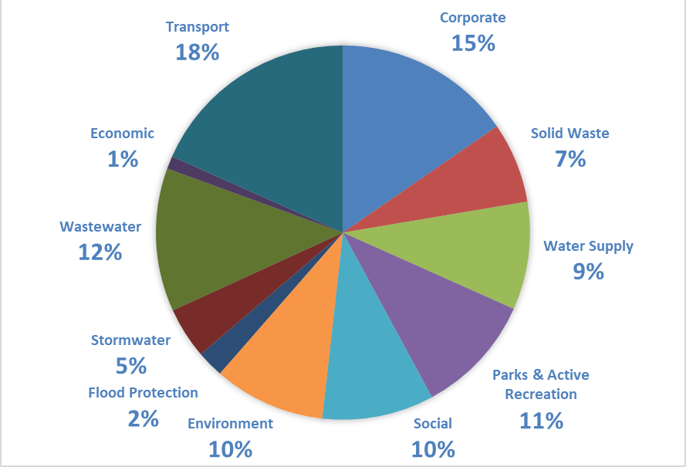

Long Term Plan 2024-2034 Capital Expenditure
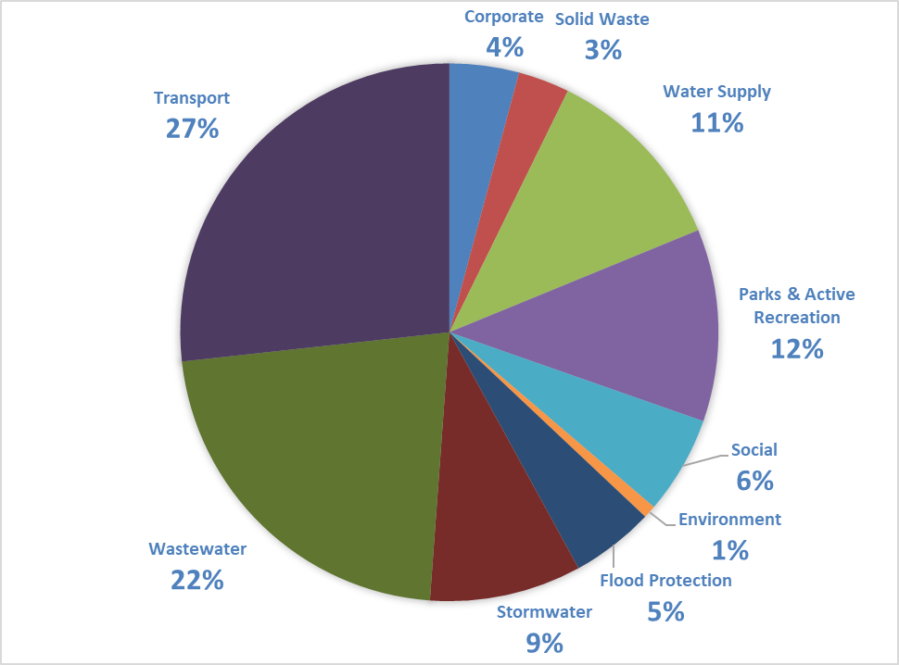

These graphs show operational and capital expenditure for the full 10 years of the Plan by Council activity.
Operational expenditure is paid for immediately from rates received that year.
Capital expenditure is funded by debt. These costs are paid off over a long period of time (commonly 80 – 100 years).
A capital project worth tens of millions of dollars can have a smaller impact on rates in any one year than a much smaller operational expenditure, but interest will be charged each year until the debt has been paid off.

Council is planning to spend $1.041 billion on new and renewal projects (capital expenditure - including inflation and excluding vested assets and the joint business units) over the 10 years of the Plan. We have assumed that we will spend 90% of our annual capital expenditure budget, as we expect some delays and some project contingencies may not be fully spent (refer to Significant Forecasting Assumptions at nelson.govt.nz for further details).

Proposed rates cap and debt cap
Rates cap proposal
Council is proposing to retain the rates cap from the existing Long Term Plan 2021-2031 of an overall increase in rates required each year of Local Government Cost Index (LGCI) plus 2.5% plus growth. This approach acknowledges that Council’s costs (particularly in relation to infrastructure) may escalate above general inflation because of the different basket of goods that drive Council costs. Also, it provides leeway for Council to maintain services to the community, or choose to increase them if public feedback indicates an appetite for this.
Projected annual rates increase versus rates cap
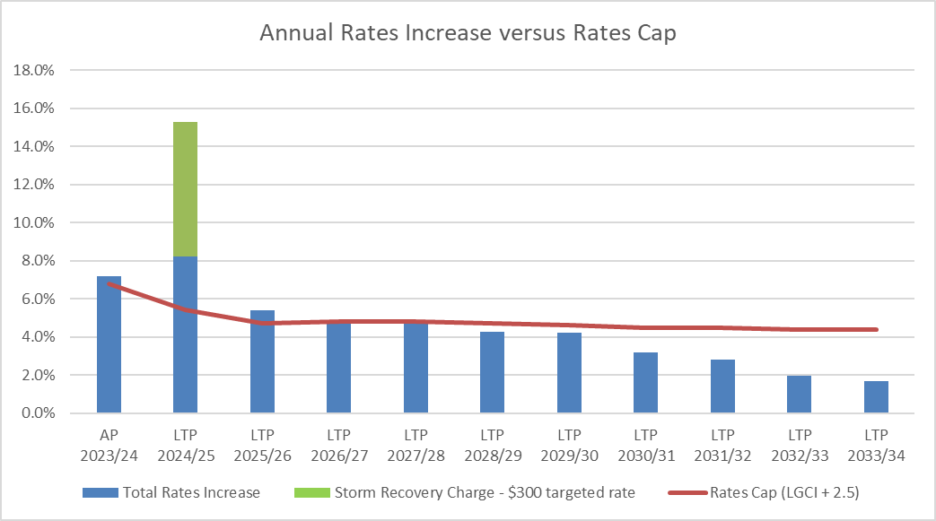
Recovery targeted rate charged for 10 years, but only contributes to the projected rates increase in the first year.
Note: The rates increase resulting from the recovery targeted rate of $300 (GST inclusive) is shown in the first year of the Plan (2024/25). The targeted rate will continue to be charged for the following nine years, but will not have an impact on projected rates increases for those years.
Debt cap proposal
Council is proposing to increase its debt cap from 175% to 200% of revenue.
Council is currently in a good debt position with reasonably low debt to revenue levels compared to many councils. Council has assets valued at $2.4 billion and net debt of $208 million (projected for June 2024), and it is projected that by 2034 our assets will be worth $3.8 billion and our net debt $526 million.
The current debt cap (debt affordability benchmark) is that net external debt is not to exceed 175% of revenue. Increasing the debt cap is considered appropriate to provide for the funding of asset renewals, the recovery works from the August 2022 severe weather event, and limit rates rises. Not increasing the debt cap would require a further significant reduction in the capital programme over the Long Term Plan (of at least $65 million). The proposed increase in the debt cap is also affordable, noting that the Local Government Funding Agency (LGFA) sets a maximum debt cap for councils of 280%.
Projected debt versus debt cap
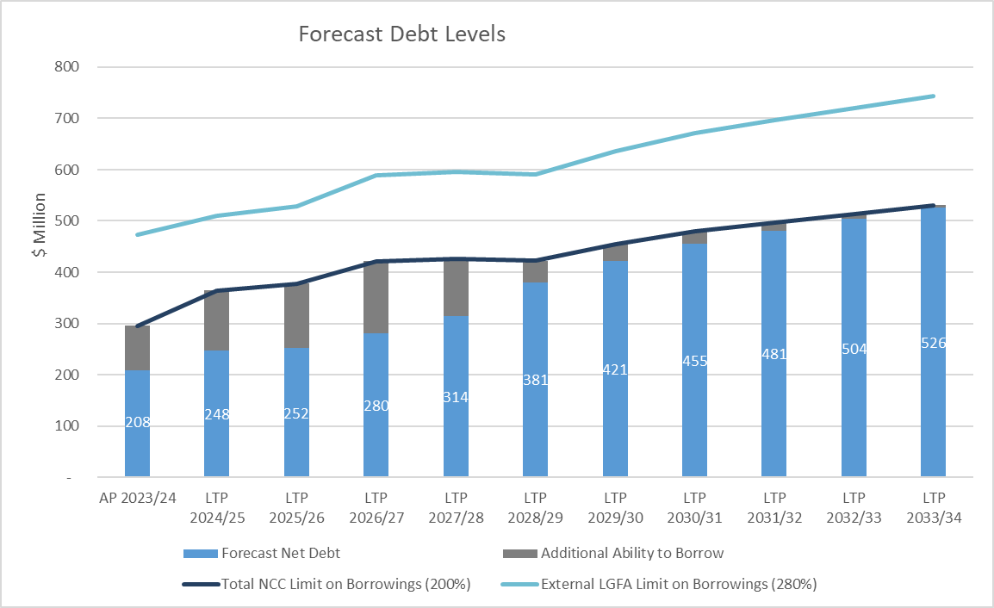
General Emergency Fund
Due to the ongoing impacts of COVID over the last four years, including the 0% rates increase in 2020/21, the General Emergency Fund has a projected overdrawn balance at 30 June 2024 of $14.8 million. As part of the next Long Term Plan process (in 2027), Council will consider how to replenish the overdrawn General Emergency Fund which will likely lead to increased rates in the later years of the Long Term Plan.
Extreme weather events are unpredictable but expected to increase as a result of climate change. Should an event occur while the Emergency Fund has insufficient funds, Council will need to borrow to cover the shortfall. Council may also reconsider, from time to time, the amount transferred to this Fund from rates, particularly if a significant event should occur.

Rating proposals
Council’s financial approach includes rating proposals to transparently fund our services. The key proposals are explained below and included in the Draft Revenue and Financing Policy.
Recovery targeted rate
Council is proposing a ‘Storm Recovery Charge’ targeted rate for the next 10 years to pay off the cost of the recovery from the August 2022 severe weather event.
The total estimated cost of the recovery is $87.2 million, with some of this to be paid for by insurance and central government. That leaves about $60 million for us to pay.
We are proposing a uniform targeted rate of $300 (including GST) which will apply to all separately used or inhabited parts of a rating unit (SUIP) in Nelson. Council already uses the SUIP definition for charging the Uniform Annual General Charge and Wastewater Charges. A rating unit is typically tied to a title of land whereas a SUIP is based on separately occupied portions of a property, e.g., for a separate tenancy, lease, or license. So, the targeted rate would also apply to individual units of accommodation within retirement villages, multi-unit residential properties and individual commercial tenancies as SUIPs within a rating unit. Taking this approach spreads the cost of recovery to a wide group of ratepayers and reduces the charge’s annual amount.
We think this is the most transparent way to pay for the recovery. Council is comfortable with setting a uniform rate, rather than a rate based on land or capital value. Council has formed this view following consideration of the impact on ratepayers of the full rating package, including the stormwater and flood protection rating proposal changes below (particularly the proposal for the general flood protection rate to be based on land value).
We need to pay this off over a relatively short period because we expect more natural disasters and intense storm events to come our way in the future. But paying off this debt faster means higher costs in the short term. If we had not been able to get Central Government support the targeted rate would be much higher – approximately $450.
Splitting the stormwater and flood protection targeted rate and changes to flood protection rate
Council is proposing to charge two separate rates – for stormwater and for flood protection.
Currently, we charge a combined rate for stormwater and flood protection as a uniform charge for all ratepayers (excluding most rural rating units, rating units east of the Gentle Annie Saddle and on Saxton Island and Council’s stormwater network). Multiple weather events over the last decade have resulted in an increase in flood protection costs, so as we invest in resilience works it is fairer and more transparent to split the rate into two.
We are planning to extend the flood protection rate to cover the entire Nelson region (excluding Saxton Island ratepayers and Council’s stormwater network) to better reflect the areas benefiting from the flood protection work we are doing. The rate would be based on land value. It would also be fairer if the flood protection work was funded as a land-value rate rather than a uniform charge as larger property owners would pay a fairer share.
The stormwater targeted rate would continue to be set as a uniform charge per rating unit but excluding rating units in the rural zone.
Forestry and Rural category land
Council is proposing to split Forestry from the Rural category, and not apply the negative 35% differential to the Forestry category land. This would mean forestry land would no longer receive a 35% discount on general rates, while we would continue to make the differential available to other rural ratepayers. This better reflects the downstream costs and impacts of forestry, including on Council’s infrastructure, like roads.

If you want to have your say on these rating proposals – make sure to comment on them through the ‘Other related consultations’ at nelson.govt.nz.

Rates remissions
Also, we are proposing rates remission changes, which are noted below and discussed in the Draft Rates Remission Policy.
Draft Rates Remission Policy changes:
- Removing the remission for heritage buildings
- Removing the remission for underground utilities
- Removing the remission of Clean Heat Warm Homes voluntary targeted rate (as it is no longer being used)
- Removing ‘other remissions deemed fair and equitable’ category (as the provision has not been used)
- Amending the remission for residential properties in commercial/ industrial areas
If you want to have your say on these proposed rates remission changes – make sure to comment on them through the ‘Other related consultations’ on nelson.govt.nz.

Impact on rates of our financial approach
To help show the impact of our financial approach on rates, the rate changes between 2023/24 and the first year of the Long Term Plan, 2024/25, are summarised for a selection of properties on the next page. Please note this is a guide and current as at February 2024. The table is GST inclusive.
The actual proposed rates increase for each property is available at nelson.govt.nz/rates-search

Example of total impact of general and targeted rates on different land uses and values
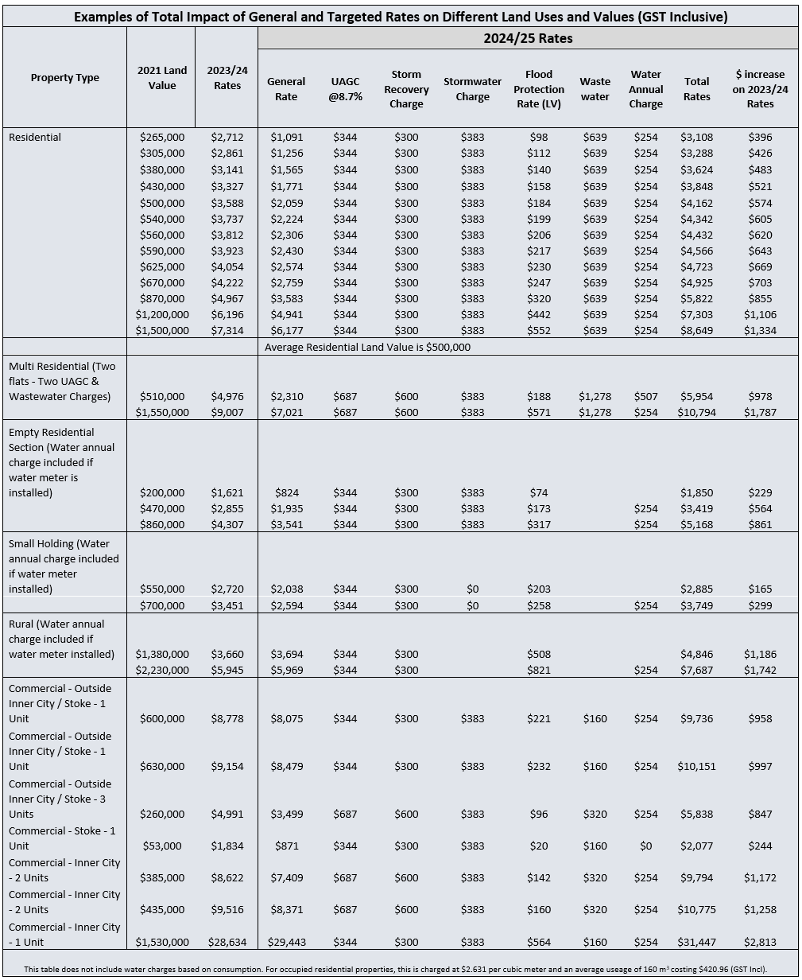

Other related consultations
Ko ētahi atu whakawhitinga
We are reviewing and updating a range of other policies as we develop our Long Term Plan. Many of them directly support our plan and reflect the priorities and work programmes that we want to progress over the next 10 years. We want to hear from you on these changes as well – go to nelson.govt.nz to have your say on any of the draft policies you are interested in.
Significance and Engagement Policy
The Significance and Engagement Policy explains how Council decides how significant a matter is when it is making decisions on that matter. This can determine when and how the community can expect to be engaged by Council prior to a decision being made.
Revenue and Financing Policy
The Revenue and Financing Policy explains ’who pays and why’ for each of the Council’s activities, such as transport, environmental management, and parks and active recreation.
Rating policies – Policy on Remission and Postponement of Rates on Māori Freehold Land, Rates Remission Policy, and Rates Postponement Policy
These policies outline the different rates relief or rates postponement options that may be available to Nelsonians.
Development Contributions Policy
The purpose of the Development Contributions Policy is to ensure property developers pay their share toward the extra costs that come with the increase in demand on Council assets and infrastructure. The update includes proposed increases in development contributions.
Schedule of Fees and Charges 2024/25
To lessen the burden on ratepayers we have also reviewed our schedule of fees and charges with the aim of moving more of the costs onto the users of services and decreasing the subsidy paid by ratepayers. Proposed changes include fees and charges for the York Valley Landfill facility and Nelson Waste Recovery Centre, regulatory functions under the Resource Management Act 1991 and Food Act 2014, some Marina services and public health licences.

Take a look at the updated draft policies and schedule under ‘Other related consultations’ at nelson.govt.nz.

Audit Opinion
Whakaaro Arotake
To the reader
Independent auditor’s report on Nelson City Council’s
consultation document for its proposed 2024-2034 long-term plan
I am the Auditor-General’s appointed auditor for Nelson City Council (the Council). The Local Government Act 2002 (the Act) requires the Council to prepare a consultation document when developing its long-term plan. Section 93C of the Act sets out the content requirements of the consultation document and the Council requested me to audit the consultation document. I have carried out this audit using the staff and resources of Audit New Zealand. We completed our audit on 22 March 2024.
Opinion
In our opinion:
- the consultation document provides an effective basis for public participation in the Council’s decisions about the proposed content of its 2024-34 long-term plan, because it:
- fairly represents the matters proposed for inclusion in the long-term plan; and
- identifies and explains the main issues and choices facing the Council and city, and the consequences of those choices; and
- the information and assumptions underlying the information in the consultation document are reasonable.
Basis of opinion
We carried out our work in accordance with the International Standard on Assurance Engagements (New Zealand) 3000 (Revised) Assurance Engagements Other Than Audits or Reviews of Historical Financial Information. In meeting the requirements of this standard, we took into account particular elements of the Auditor-General’s Auditing Standards and the International Standard on Assurance Engagements 3400 The Examination of Prospective Financial Information that were consistent with those requirements.
We assessed the evidence the Council has to support the information and disclosures in the consultation document. To select appropriate procedures, we assessed the risk of material misstatement and the Council’s systems and processes applying to the preparation of the consultation document.
We did not evaluate the security and controls over the publication of the consultation document.
Responsibilities of the Council and auditor
The Council is responsible for:
- meeting all legal requirements relating to its procedures, decisions, consultation, disclosures, and other actions associated with preparing and publishing the consultation document and long-term plan, whether in printed or electronic form;
- having systems and processes in place to provide the supporting information and analysis the Council needs to be able to prepare a consultation document and long-term plan that meet the purposes set out in the Act; and
- ensuring that any forecast financial information being presented has been prepared in accordance with generally accepted accounting practice in New Zealand.
We are responsible for auditing the consultation document and reporting on the matters described in sub-sections 93C(4)(a) and 93C(4)(b) of the Act, as agreed in our Audit Engagement Letter. We do not express an opinion on the merits of any policy content of the consultation document.
Independence and quality management
We have complied with the Auditor-General’s independence and other ethical requirements, which incorporate the requirements of Professional and Ethical Standard 1 International Code of Ethics for Assurance Practitioners (including International Independence Standards) (New Zealand) (PES 1) issued by the New Zealand Auditing and Assurance Standards Board. PES 1 is founded on the fundamental principles of integrity, objectivity, professional competence and due care, confidentiality, and professional behaviour.
We have also complied with the Auditor-General’s quality management requirements, which incorporate the requirements of Professional and Ethical Standard 3: Quality Management for Firms that Perform Audits or Reviews of Financial Statements, or Other Assurance or Related Services Engagements (PES 3) issued by the New Zealand Auditing and Assurance Standards Board. PES 3 requires our firm to design, implement and operate a system of quality management including policies or procedures regarding compliance with ethical requirements, professional standards and applicable legal and regulatory requirements.
In addition to this audit, and our report on the Council’s 2022-23 annual report, we have carried out a limited assurance engagement related to the Council’s debenture trust deed, which is compatible with those independence requirements. Other than these engagements we have no relationship with or interests in the Council or any of its subsidiaries.

John Mackey
Audit New Zealand
On behalf of the Auditor-General, Christchurch, New Zealand

How to have your say
Whakahoki kōrero mai
This is your chance to have a say on Council’s most important plan – we want to hear from you!
Please look through what we propose, consider your priorities, and let us know what you think by 28 April 2024.
Submissions can be made:
- Online at nelson.govt.nz
- Dropping off to Civic House, 110 Trafalgar Street, Nelson
- By post to Nelson City Council, PO Box 645, Nelson 7040. Freepost 76919
- By email to submissions@ncc.govt.nz
- By calling the Customer Service Centre if you would like assistance to complete a submission on 03 546 0200
Consultation documents are available from:
• Online at nelson.govt.nz
• Our Customer Service Centre at the corner of Trafalgar and Halifax Streets
• The public libraries in Nelson, Tāhunanui and Stoke
More information
    - Online – Supporting information is available on our website at nelson.govt.nz
    - Talk to a person – Call us on 03 546 0200 to answer your questions or send you more information

Submission form
Submissions close 28 April 2024
Puka whakahoki kōrero
Long Term Plan 2024-2034 Consultation Document
Name: ______________________________________________________________________
Organisation represented: (if applicable) _______________________________________
Address: ____________________________________________________________________
Email: ______________________________________________________________________
Phone: ______________________________________________________________________
Age: (please select one)
Ο 15 years and under Ο 16 to 24 years Ο 25 to 39 years Ο 40 to 64 years
Ο 65 to 79 years Ο 80 years or over Ο Prefer not to say
Ethnicity: (Please select all that apply)
Ο New Zealand European / Pākehā Ο Māori Ο Samoan
Ο Cook Islands Māori Ο Tongan Ο Niuean Ο Chinese Ο Indian
Ο Other (please specify) Ο Prefer not to say
Do you wish to speak at the hearing? Yes / No ____________________________________
If you do not circle either, we will assume you do not wish to be heard. If you wish to present your submission at the hearing in Te Reo Māori or New Zealand sign language please include this information in your submission.

How to fill in this form
We know how busy everyone is and really appreciate you taking the time to provide feedback. To help, here’s some tips on filling in the form.
- You don’t have to give feedback on all issues– You can choose to answer only the ones you are interested in.
- Adding comments is optional – You can choose to provide extra information in the comments sections or skip to the next question.

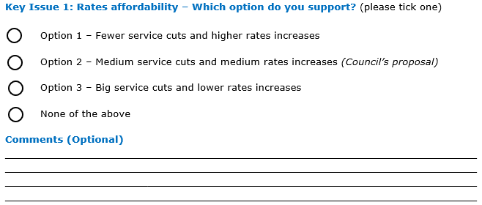
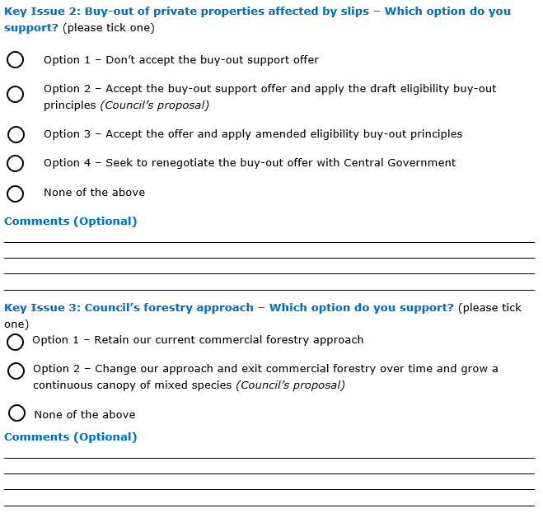

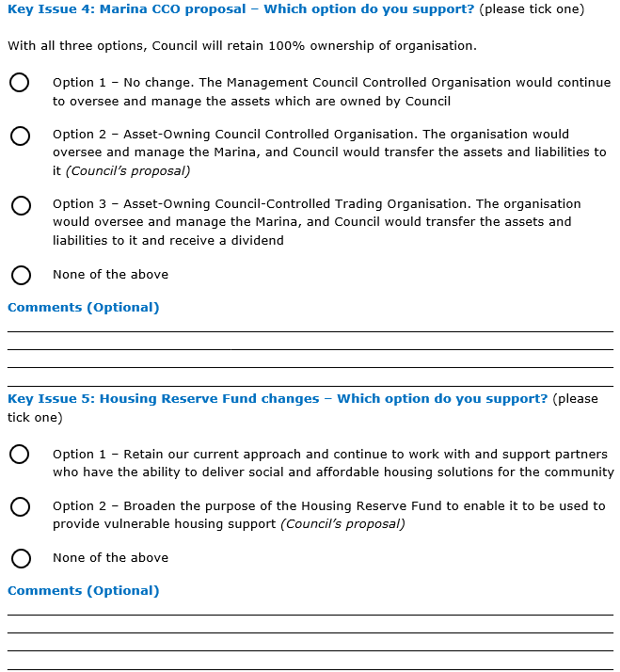
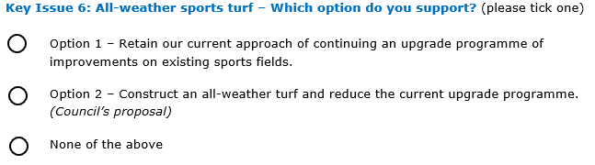

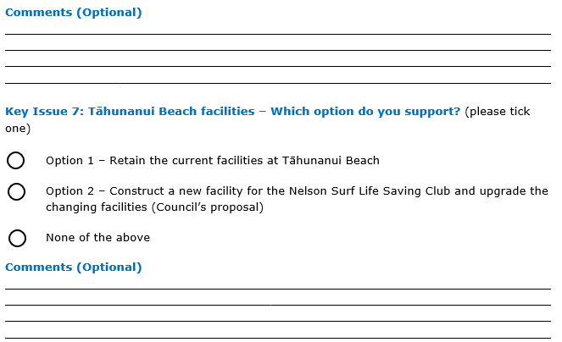
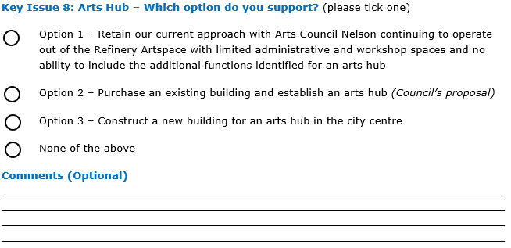

Any other comments on the Long Term Plan 2024-2034 Consultation Document (Optional)
________________________________________________________________________________________________________________________________________________________________________________________________________________________________________________________________________________________________________________
________________________________________________________________________________________________________________________________________________________
____________________________________________________________________________

Public information: All submissions (including your name and contact details) will be provided to Council workers for administration and analysing feedback, and to those who are involved in decision making on the consultation.
All submissions, including submitter names (unless you request otherwise) but not contact details, will be publicly available online. The body of your submission and any attachments will not be checked for personal information and it should be assumed that anything included in these will be made public.
Note: Council is subject to the Local Government Official Information and Meetings Act 1987 and a request for official information may cover your submission, including your address and other contact details.
Note: The Long Term Plan consultation and other related consultations will be heard together over the two days of hearings. A total of up to five minutes per person (and up to 10 minutes per organisation) is allocated to those wishing to speak to one or more of the consultations they submitted on.
Note: You may be interested to know that we are trialling the use of some artificial intelligence tools this Long Term Plan, to help speed up processing of submissions and reduce the resources used.
Note: You may be contacted following this year’s consultation to find out about your experience of the engagement process.

All numbers in this document are adjusted for inflation and exclude GST (unless otherwise stated).
For each key issue, we explain the estimated impact on levels of service (where there is any change), rates, and debt of the different options. The impact on rates is made up from known direct operational costs, interest flowing from debt needed to be borrowed, funding of the depreciation, and net of any expected income generated as a result of the project or option. Impact on debt is generally the capital costs for the project net any upfront contributions towards the cost of the project from external sources.
This is an ever increasing challenge – a recent review into the future for local government highlighted the “current local government funding and finance system is already under pressure and is not sustainable”. Page 11, Review into the Future for Local Government (2023) He piki tūranga, he piki kotuku.
Net external debt is defined as total debt cash, term deposits and borrower notes. Revenue is defined as cash earnings from rates, government grants and subsidies, user chargers, interest, dividends, and excluding development contributions, financial contributions, vested assets, gains on derivative financial instruments and revaluations of property, plant or equipment.

