Council Project Manager: Pradip Rupakheti
Email: pradip.rupakheti@ncc.govt.nz
Phone: (03) 265 5281

Infrastructure - Capital project
WORKS NOTICE – Street Safety Improvements
WHAT |  | Streets for People – Railway Reserve to Waimea Road
WHEN |  | January/February 2024
TRAFFIC |  | Lane closures
WHAT ARE WE DOING:
- This project will see the construction of raised tables and speed cushions, a widened shared path, and installing a separated cycle lane.
- The project covers: Motueka Street (crossing), Tipahi Street (by the hospital and Broads playing fields), Franklyn Street (towards Waimea Road), Kawai Street and Hampden Street West.
WHY ARE WE DOING IT:
- The Streets for People project focuses on making it safer and easier for people to use active modes of transport by connecting safe streets in the area. It also aims to improve the liveability of streets for residents.
DURATION:
- Work is due to begin late January/early February 2024. It is expected to take around 13 weeks (depending on the weather). The construction programme, along with Stage 2 road impacts, can be seen on the back of this letter.

TRAFFIC CONDITIONS:
- The works will be constructed in three stages. The first being site wide service investigation where traffic management will be in place across all four streets intermittently. This will be for around 1 week. The second stage will involve the works on Motueka Street and Franklyn Street. This will take around 4 weeks to complete. The third stage of work will involve the works on both Tipahi Street and Kawai Street/Hampden Street. This is set to take 6 weeks to complete. Please note that during the full construction period, there will be significantly reduced parking in the area.

FIND OUT MORE:
- For more information about the project, including detailed plans for the work, please visit: https://shape.nelson.govt.nz/streets-people or email the Project Manager: Pradip.Rupakheti@ncc.co.nz.

Delivery Contractor: Isaac Construction Ltd.
Site Representative: Jack Whittle. Ph: 027 938 5690 (24hr Contact)
Traffic Controller (STMS): Jordan Giles. Ph: 027 230 8338

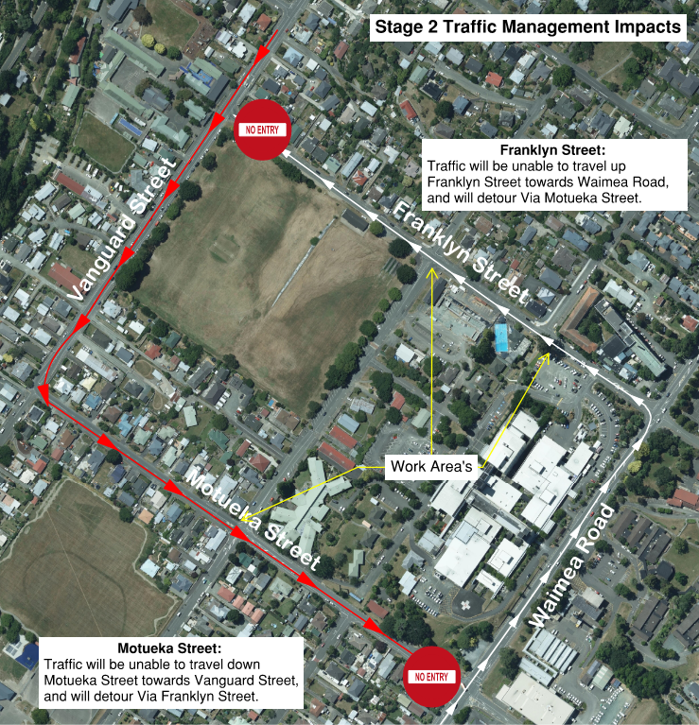
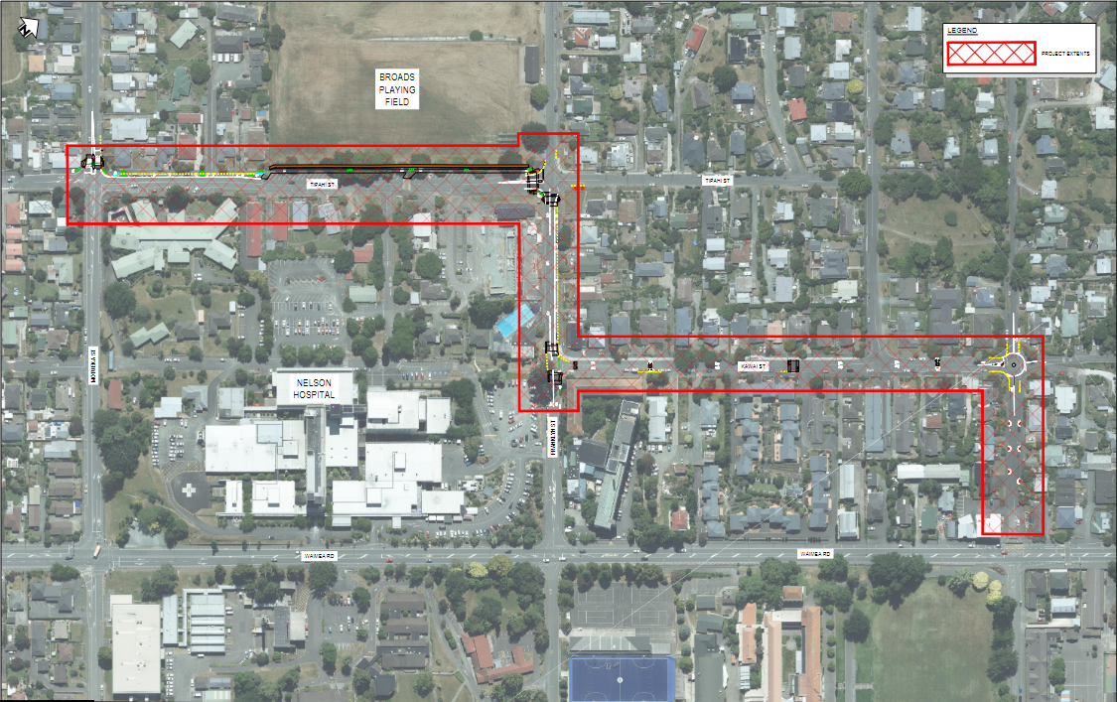
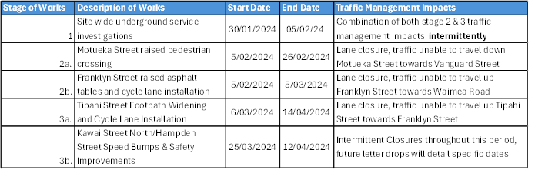
Project Area

