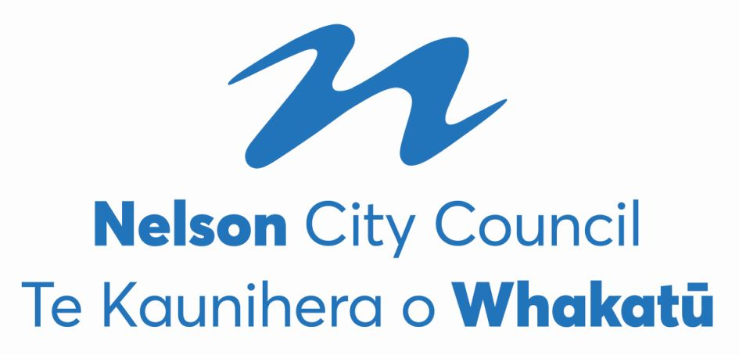

**Nelson City Council**

**2022 Triennial Elections**

**FINAL RESULT**

**The voter return was 51.14%, being 20,084 voting papers, excluding special votes.**

**The final result for the Nelson City Council elections held on Saturday 8th October is as follows.**

**Mayoralty**

|  |  |  |
| --- | --- | --- |
| **Nick Smith** | **Independent** | **Elected** |

|  |  |  |
| --- | --- | --- |
| **Matt Lawrey** |  | **Excluded** |
| **Rohan O’Neill-Stevens** |  | **Excluded** |
| **Tim Skinner** | **Nelson Citizens Alliance** | **Excluded** |
| **Kerry Neal** |  | **Excluded** |
| **Richard Osmaston** | **Money Free Party New Zealand** | **Excluded** |
| **John Wakelin** |  | **Excluded** |

**Nick SMITH is declared elected.**

**The final absolute majority of votes (final quota) as determined at the last iteration was 9,921. There were 31 informal votes and 102 blank votes.**

**Council - At Large (3 vacancies)**

|  |  |  |
| --- | --- | --- |
| **Rohan O’Neill-Stevens** |  | **Elected** |
| **Tim Skinner** |  | **Elected** |
| **Rachel Sanson** |  | **Elected** |

|  |  |  |
| --- | --- | --- |
| **Ian Williams** | **Independent** | **Excluded** |
| **Zoe Byrne** | **Nelson Citizens Alliance** | **Excluded** |
| **Mike Ward** |  | **Exclluded** |
| **Mani Rai** | **Nelson Citizens Alliance** | **Excluded** |
| **Marie Lindaya** | **Whiria te tāngata Weave together** | **Excluded** |
| **Cindy Batt** | **Work 4 U** | **Excluded** |
| **Brent Pahl** | **Independent** | **Excluded** |
| **Margot Haley** |  | **Excluded** |

**Rohan O'NEILL-STEVENS, Rachel SANSON and Tim SKINNER are declared elected.**

**The final absolute majority of votes (final quota) as determined at the last iteration was 4,579.8. There were 334 informal votes and 1,039 blank votes.**

**Central Ward (4 vacancies)**

|  |  |  |
| --- | --- | --- |
| **Pete Rainey** | **Independent** | **Elected** |
| **Aaron Stallard** | **Independent** | **Elected** |
| **Matty Anderson** | **Independent** | **Elected** |
| **James Hodgson** | **Nelson Citizens Alliance** | **Elected** |

|  |  |  |
| --- | --- | --- |
| **Peter Win** | **Nelson Citizens Alliance** | **Excluded** |
| **Cleo Cowdrey** | **Nelson Citizens Alliance** | **Excluded** |
| **Murray Cameron** | **Nelson Citizens Alliance** | **Excluded** |
| **Sean Davis** |  | **Excluded** |
| **Dai Mitchell** | **Independent** | **Excluded** |

**Matty ANDERSON, James HODGSON, Pete RAINEY and Aaron STALLARD are declared elected.**

**The final absolute majority of votes (final quota) as determined at the last iteration was 1,661.24. There were 326 informal votes and 689 blank votes.**

**Stoke-Tāhunanui Ward (4 vacancies)**

|  |  |  |
| --- | --- | --- |
| **Mel Courtney** | **Independent** | **Elected** |
| **Campbell Rollo** | **Independent** | **Elected** |
| **Trudie Brand** | **Working For You** | **Elected** |
| **Matthew Benge** |  | **Excluded** |

|  |  |  |
| --- | --- | --- |
| **Ian Barker** | **Time to work better together** | **Excluded** |
| **Valmai Palatchie** |  | **Excluded** |
| **Harvey Ruru** | **Independent** | **Excluded** |
| **Allan Douglas Hoult** | **Nelson Citizens Alliance** | **Excluded** |
| **Mike Gane** | **Independent** | **Excluded** |
| **Harry Pearson** | **Nelson Citizens Alliance** | **Excluded** |
| **Sarah Minchington** | **Independent** | **Excluded** |
| **Rhys Bromell** |  | **Excluded** |
| **Lyndell Dodunski** |  | **Excluded** |

**Matthew BENGE, Trudie BRAND, Mel COURTNEY and Campbell ROLLO are declared elected.**

**The final absolute majority of votes (final quota) as determined at the last iteration was 1,578.61. There were 271 informal votes and 533 blank votes.**

**Whakatū Māori Ward (1 vacancy)**

|  |  |  |
| --- | --- | --- |
| **Kahu Paki Paki** |  | **Elected** |

|  |  |  |
| --- | --- | --- |
| **Bernie Goldsmith** | **Work 4 U** | **Excluded** |

**The final absolute majority of votes (final quota) as determined at the last iteration was 183. There were 6 informal votes and 33 blank votes.**